# CSA SCENERIO-CASES

1. Import your batch members as 20 users into your personal developer environment through import set
   * 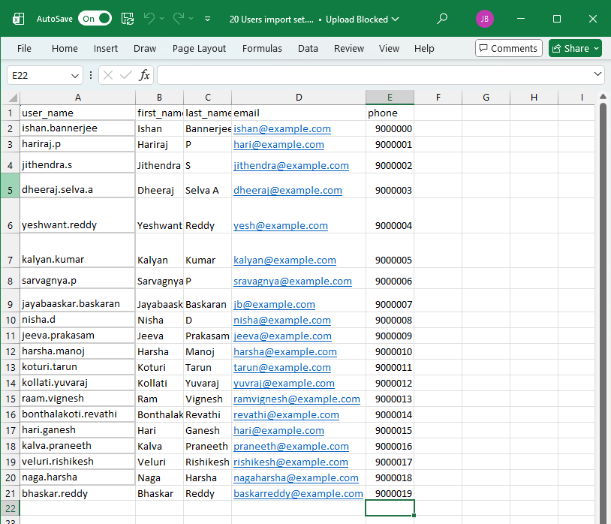Import data – Excel Format
   * 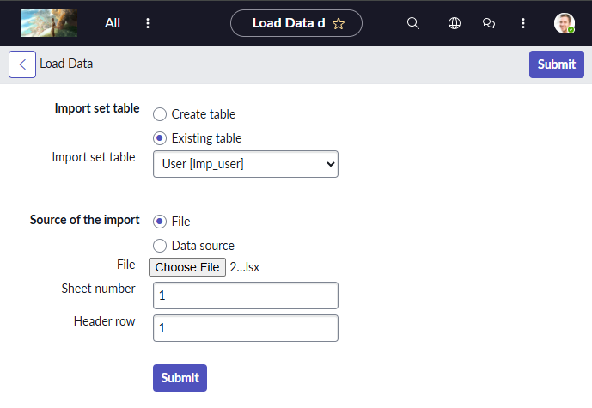To import data from excel sheet : All > Import Sets > Load Data
   * 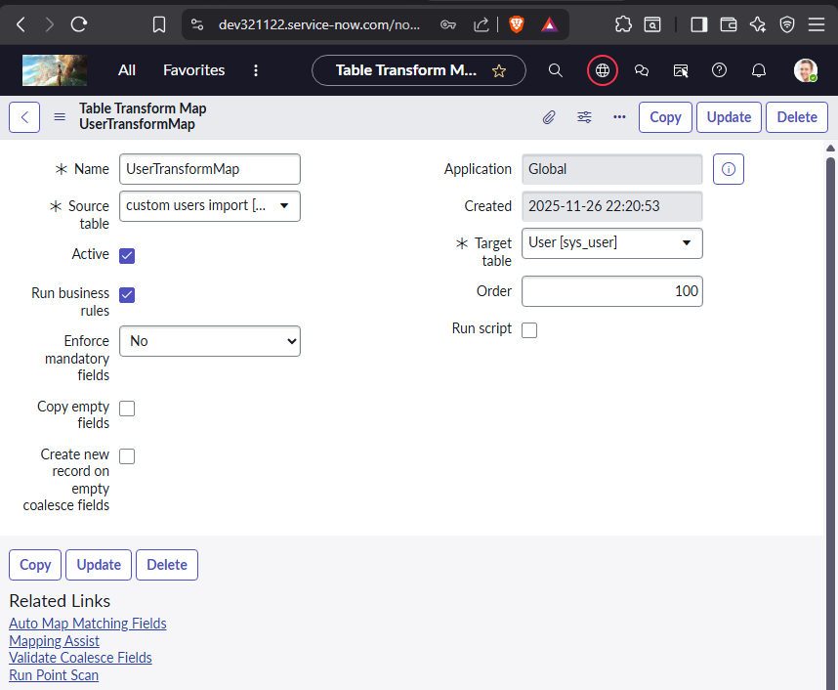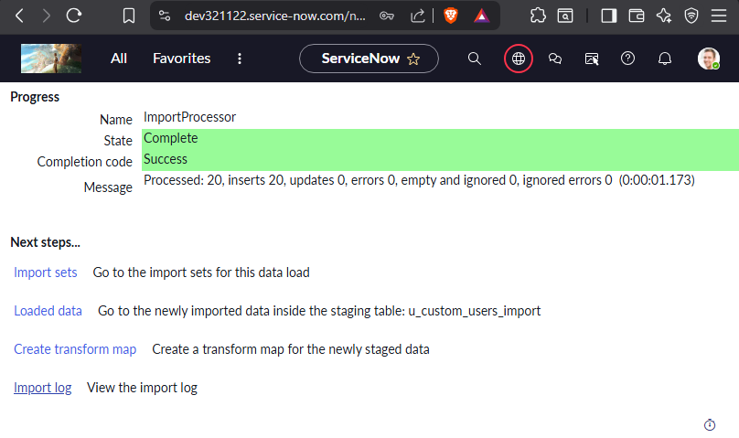Create Transform Map for Mapping fields
   * 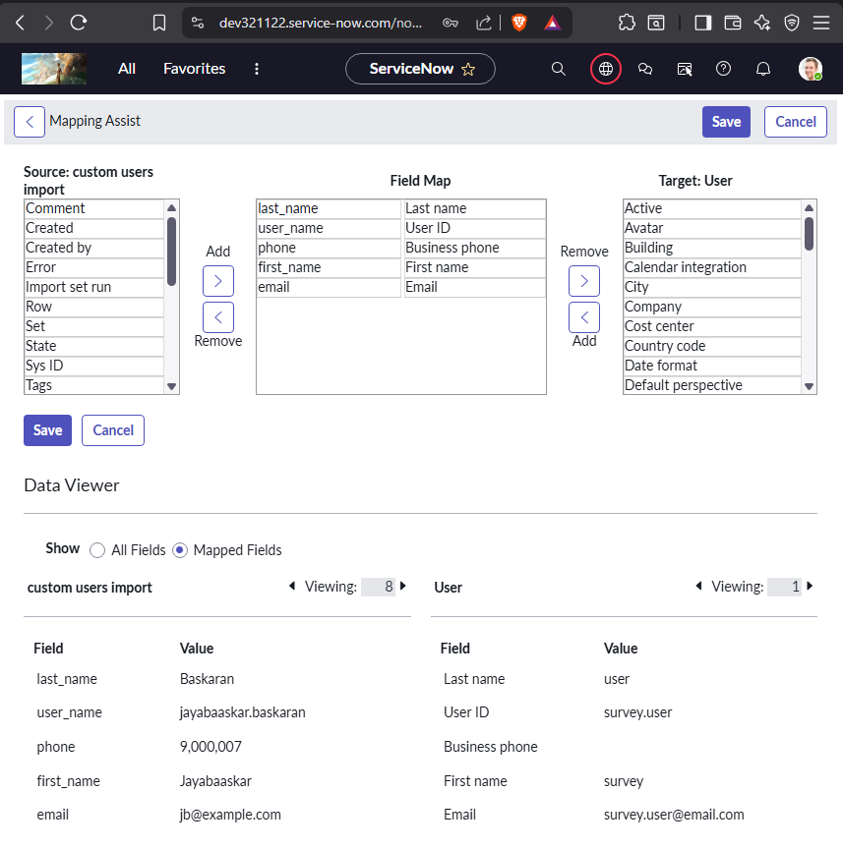Using Mapping Assist Map fields properly
   * 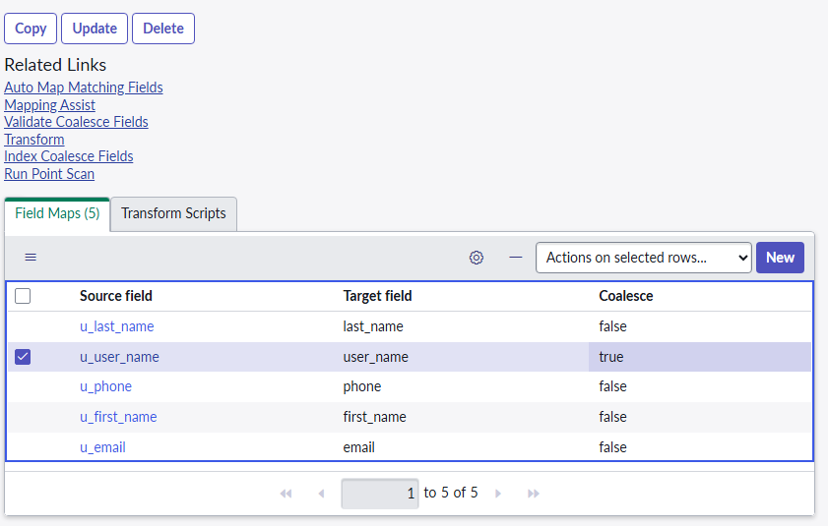Check the Coalesce Field true for the Unique fields to make sure there are no duplicates in the future and to update
   * 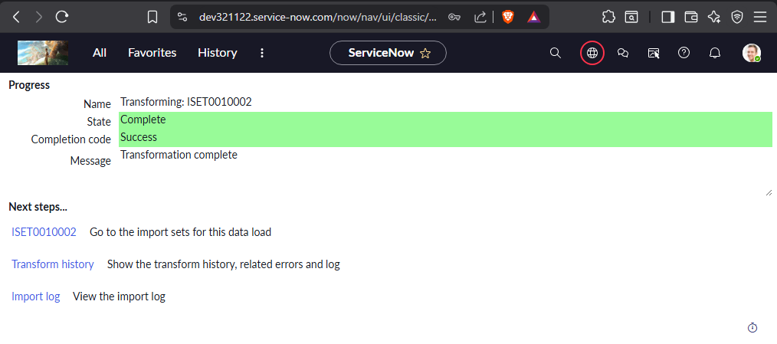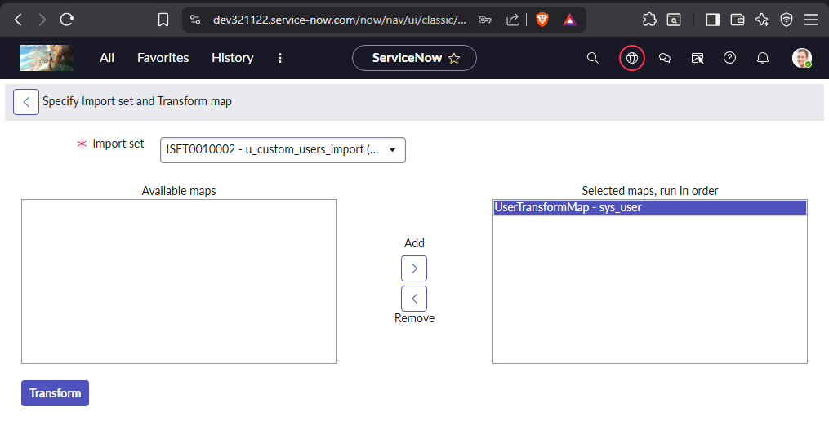Run the Transform Map Created
   * 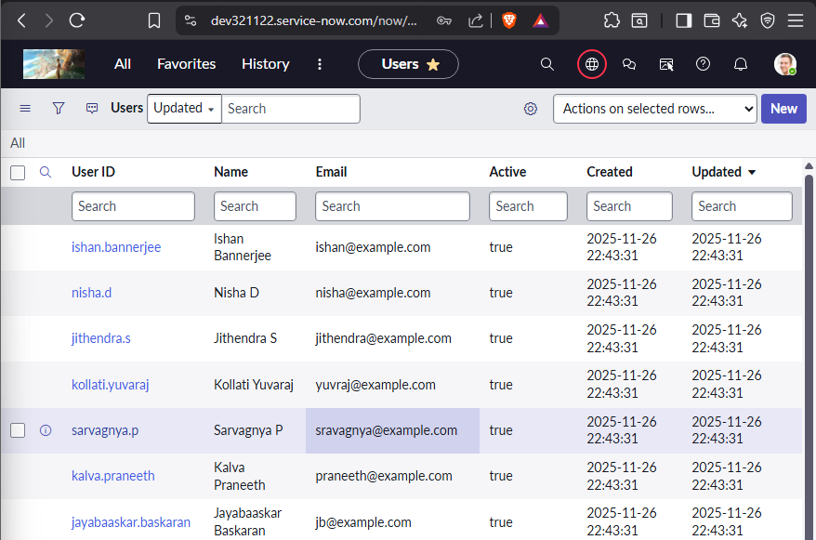Check the User table for imported Users and details.

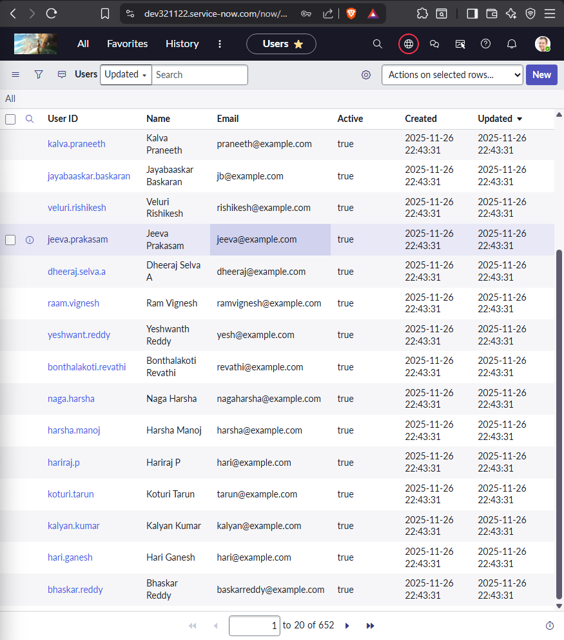

1. Create 3 groups called Batch-1 and Batch-2 and Batch-3.
   * Go to Groups under User Administraion – All > User Administration > Groups >New
   * 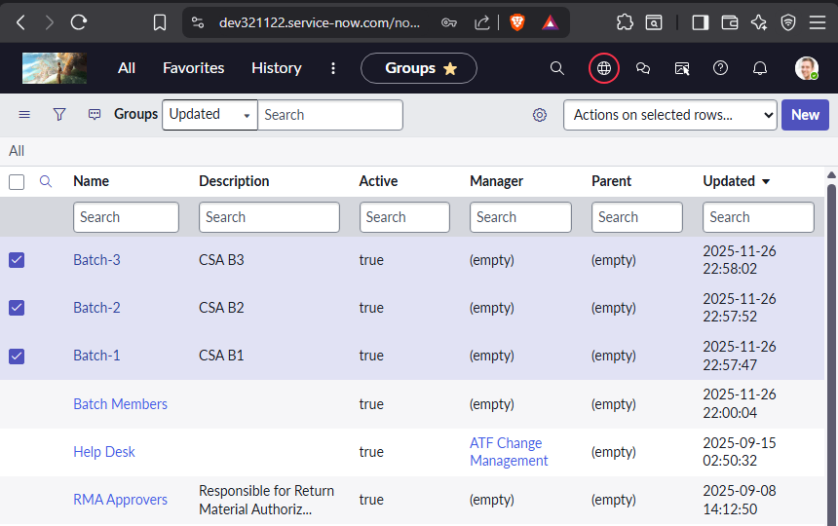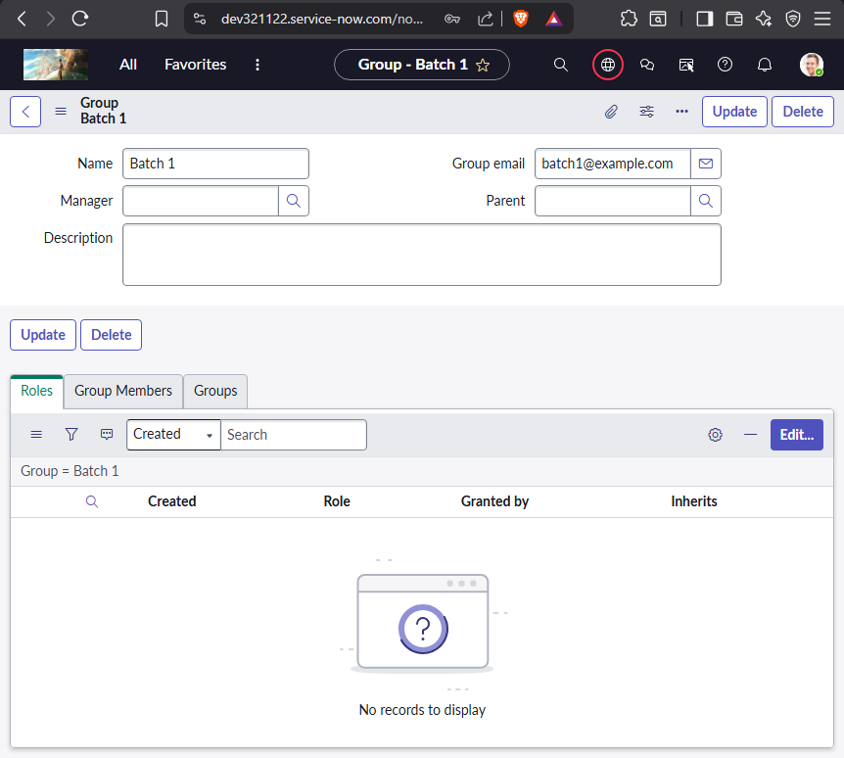Table Name: sys_user_group
2. Create Assignment lookup rules when category is software the assignment group should be software.
   * Go to Assignment Data Lookup table – table name – dl_u_assignment
   * 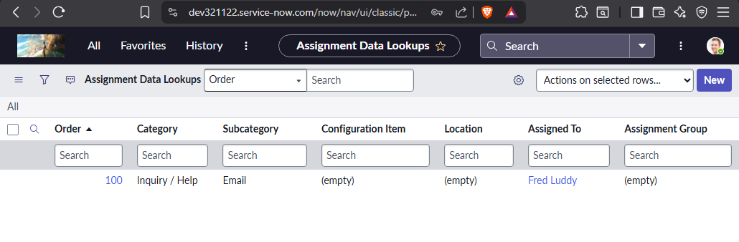Type dl_u_assignment.list on All Filters and Enter to open the table.
   * 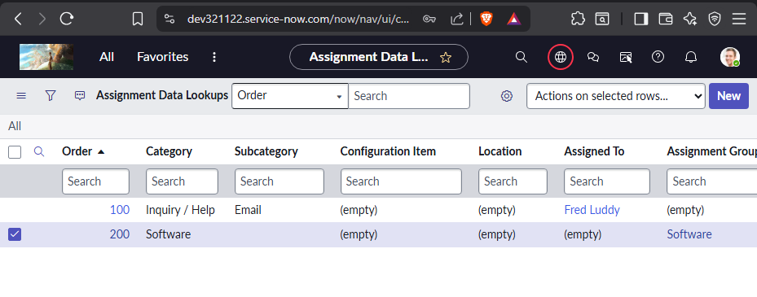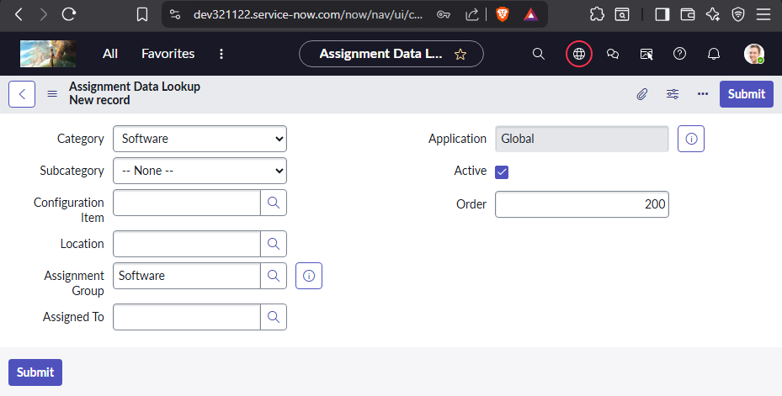Create New Data Lookup for Software
   * 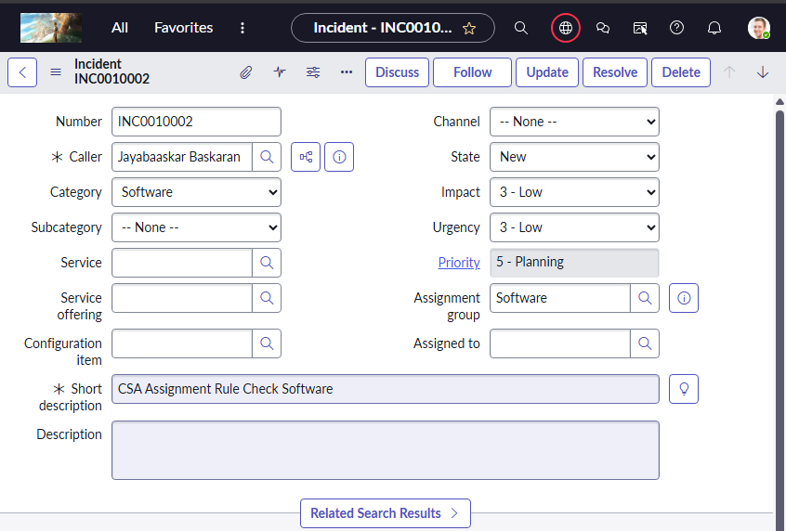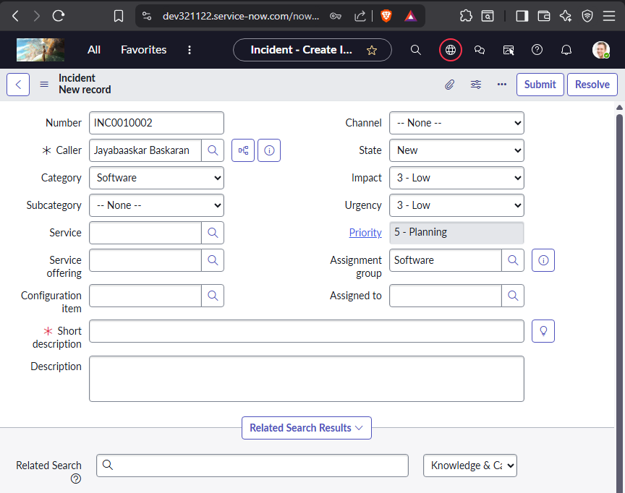Check If the assignment work in Incident Table
3. Create a custom table to store Credit card request details.
   * 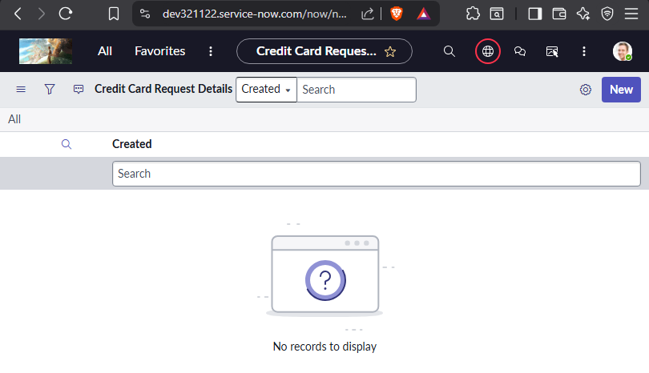custom table name – u_credit_card_request_details.
   * 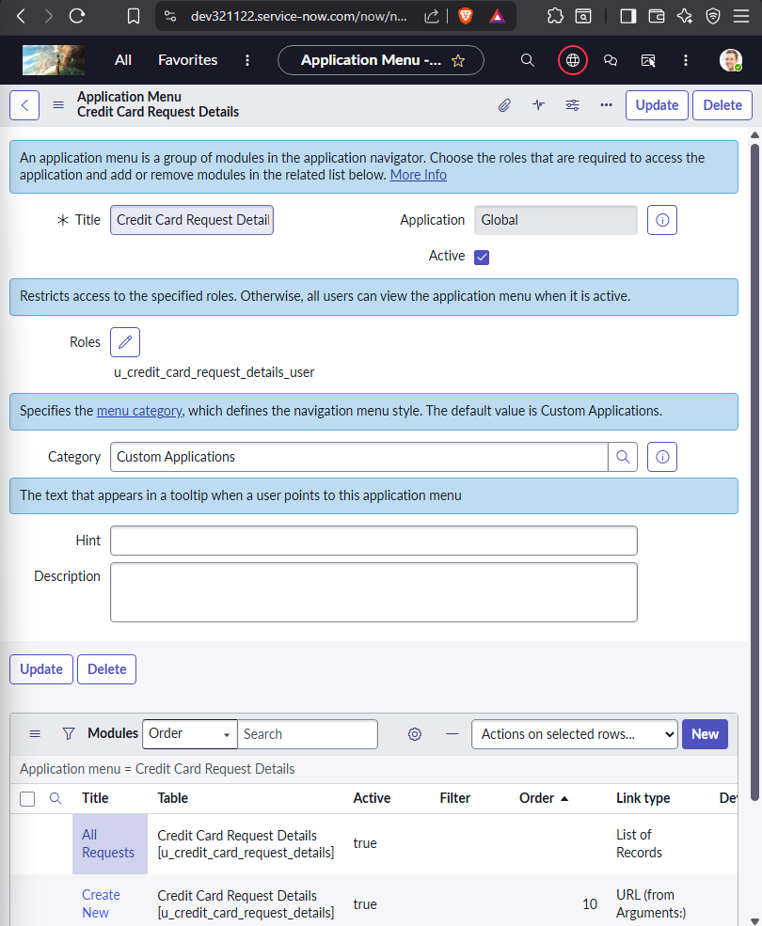Along with an application with the same name is created
   * 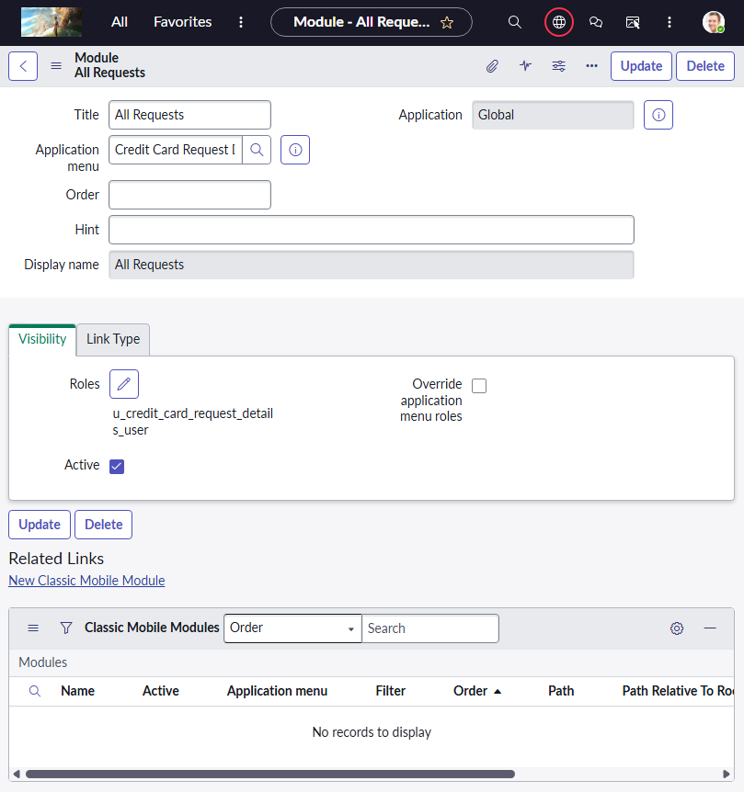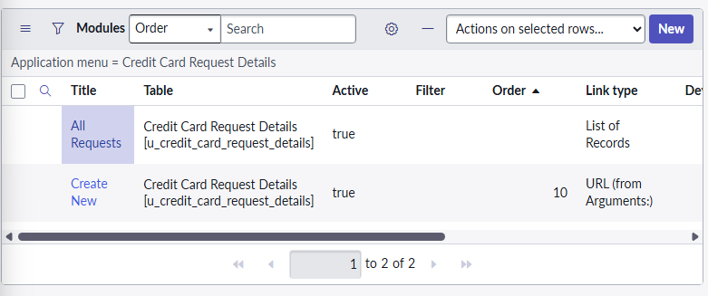Module –Create New & All Request & My Request
   * 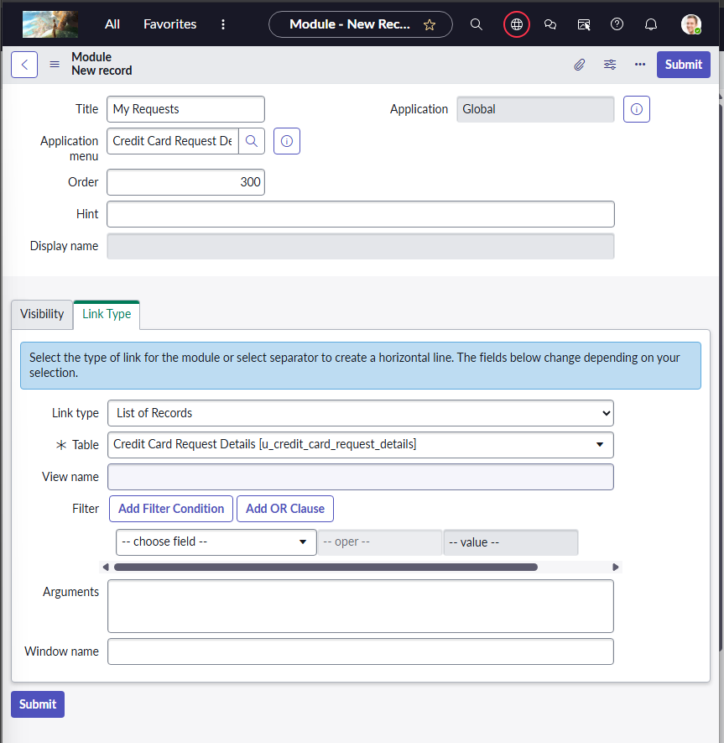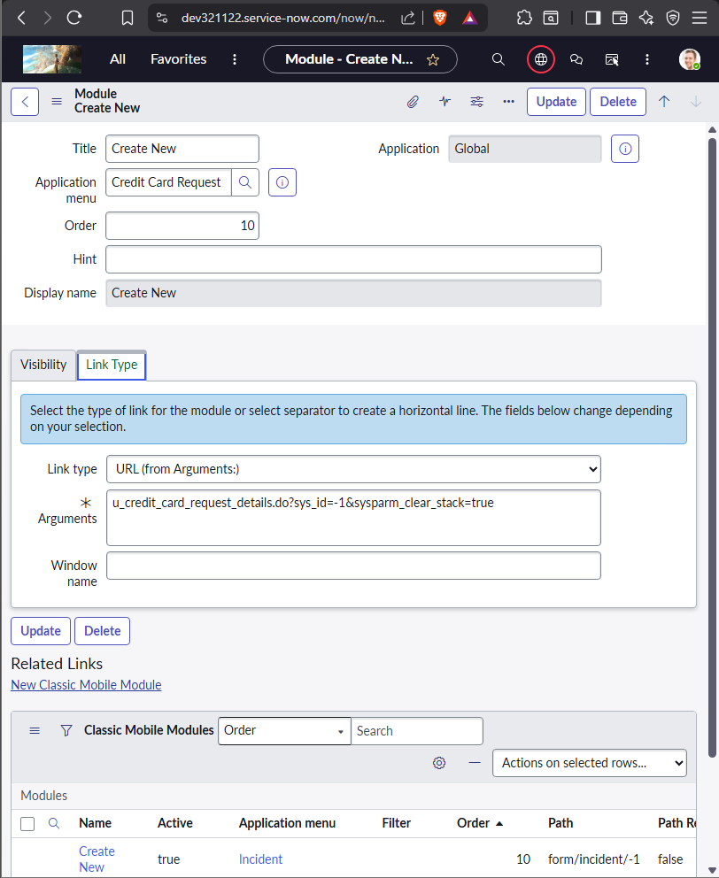Add Link type URL and in Arguments add the Form link Suffix for Create New
   * 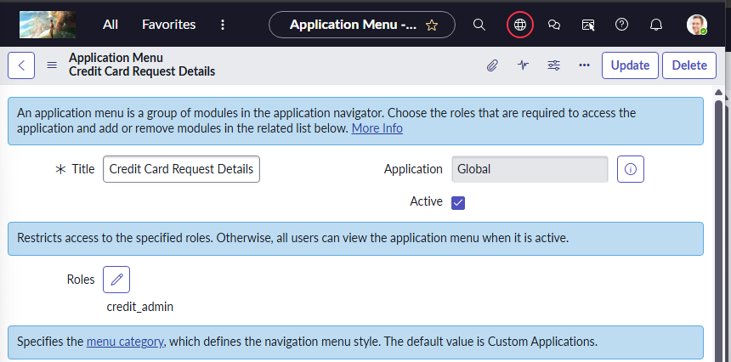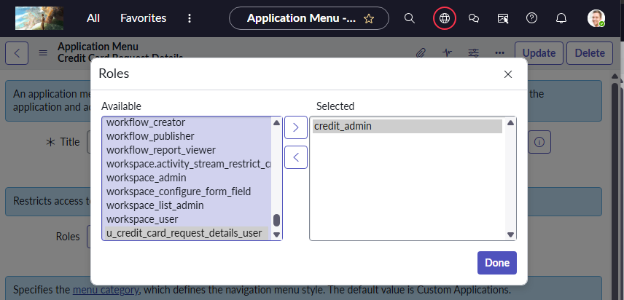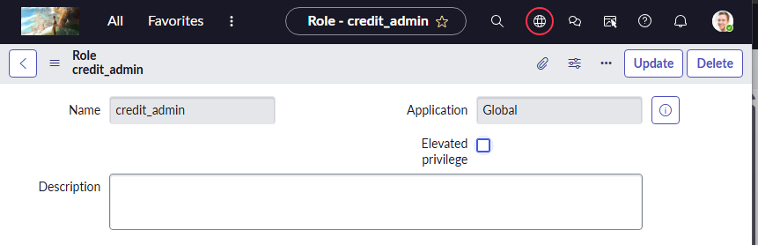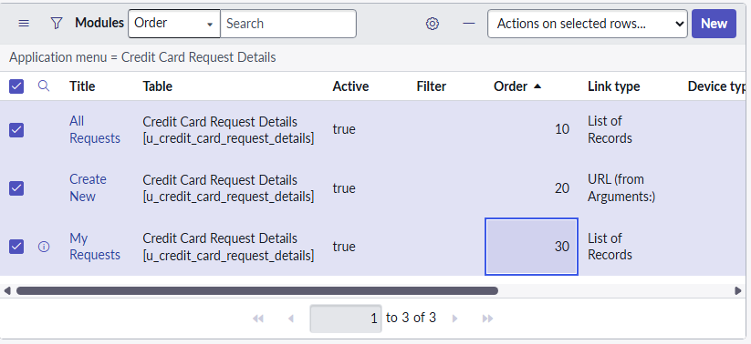Custom Role Creation credit_admin for application
   * 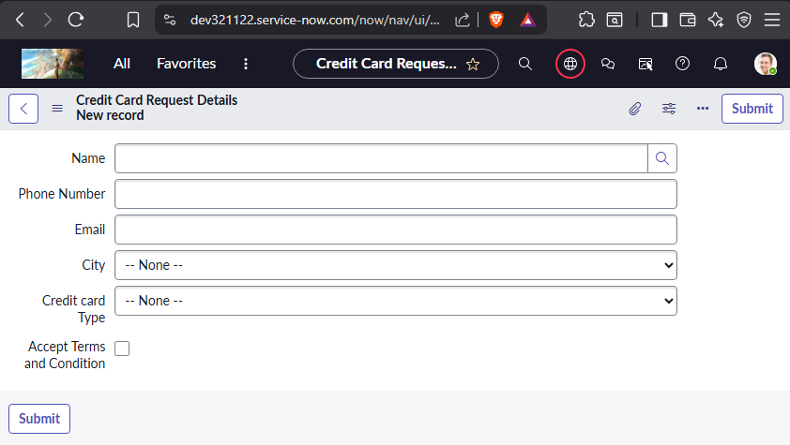Required fields: 1) Name: refer to user table. 2) Phone Number: String 3) Email: String 4) City: Choice type –All metro cities. 5) Credit card Type: any 4 choices as your wish. 6) Accept Terms and Condition: check box
   * Using Either Form Builder or Form Layout create Fields add choices
   * 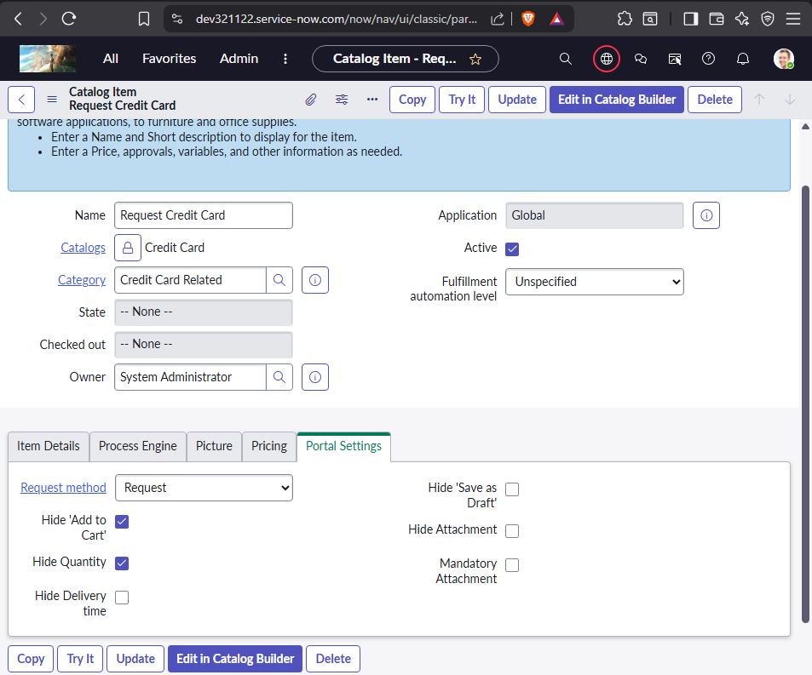Create catalog to request credit card *Required Variables 1) Name : refer to user table.-→mandatory 2) Phone Number : String 3) Email : String 4) City : Choice type –All metro cities. 5) Credit card Type: any 4 choices as your wish. 6) Accept Terms and Condition : check box-→if not accepted then catalog should not be submitted and need to alert user “please accept the T&C”

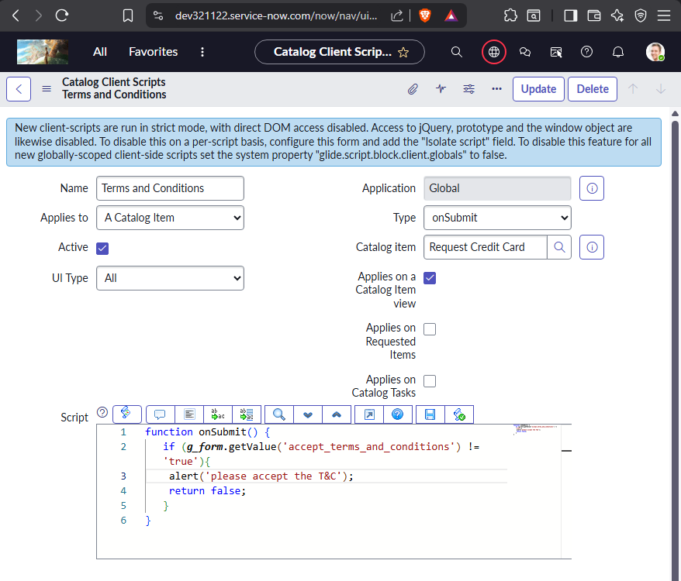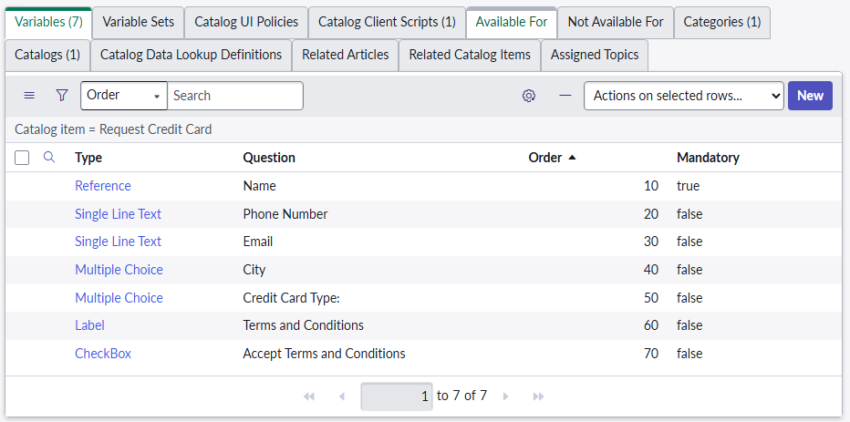

* + 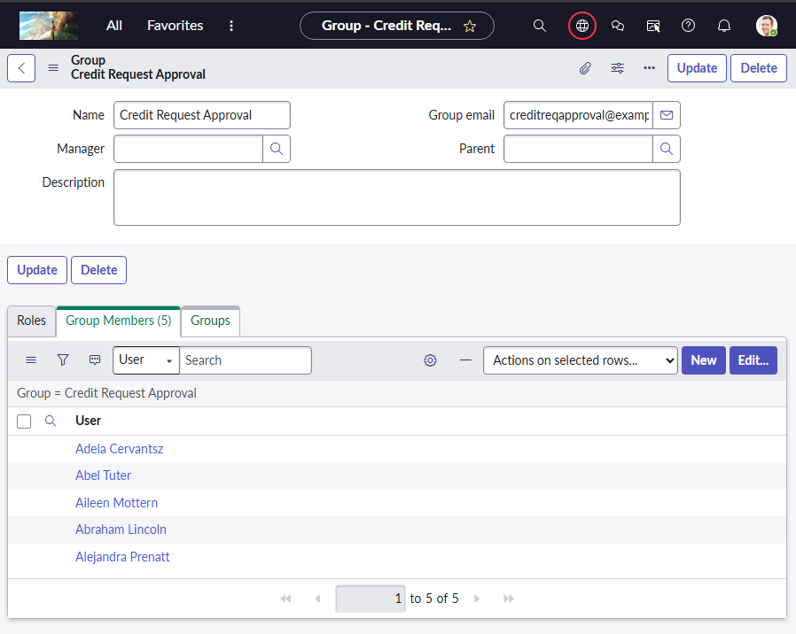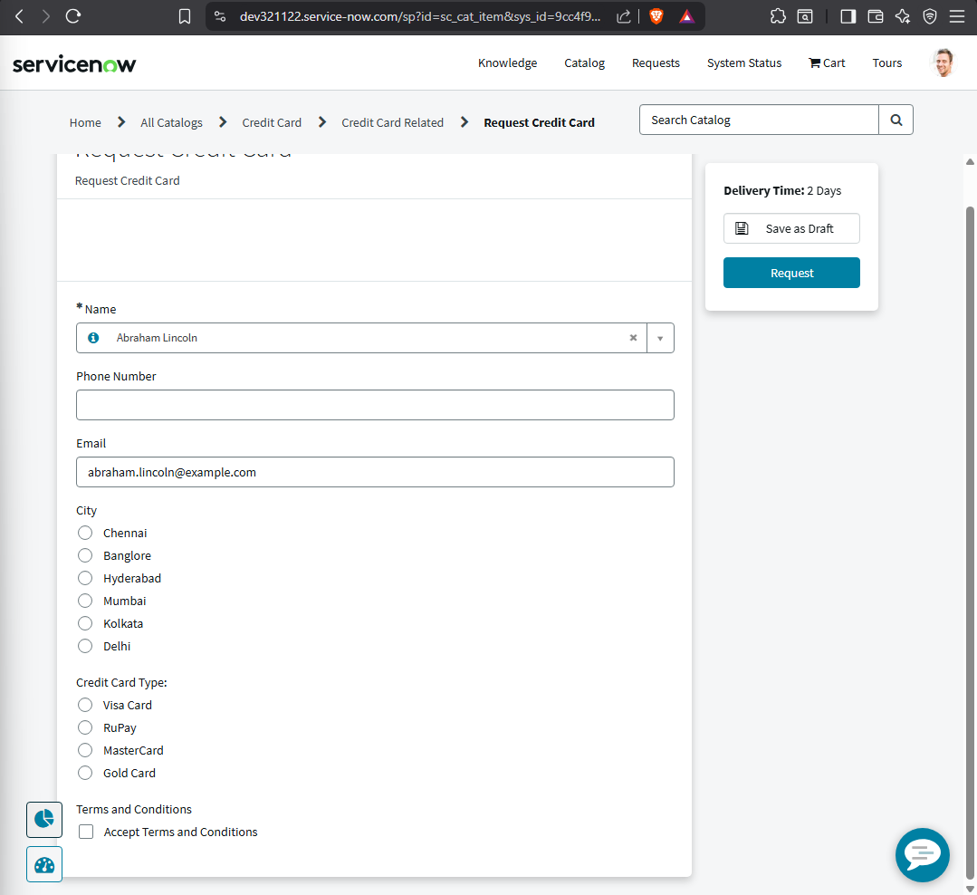Create Group Credit req approval group. Add the few user to this group.

1. Once user requested the credit card service it should go approval for Credit req approval group.
   * + 1) If approval approved then need to create a document verification task.
     + 2) if rejected or completed then notify the user with rejected content or approved content.
     + 3) if task completed successfully then create a delivery task.
     + 4) if delivery task completed then need to close RITM and Req records.
     + 5) if delivery task closed incomplete, then notify user req has not been processed and incomplete the req and ritm.
     + 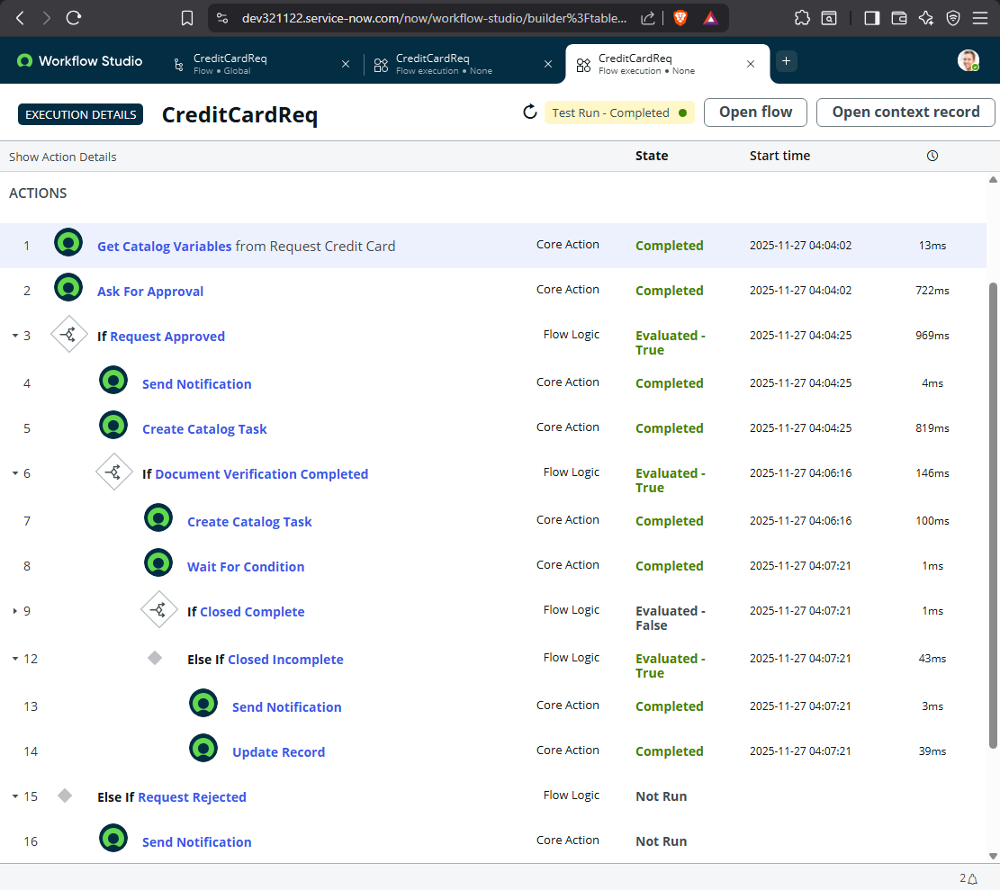6) The Assignment group for above tasks should be i.e., Credit req approval group.
     + 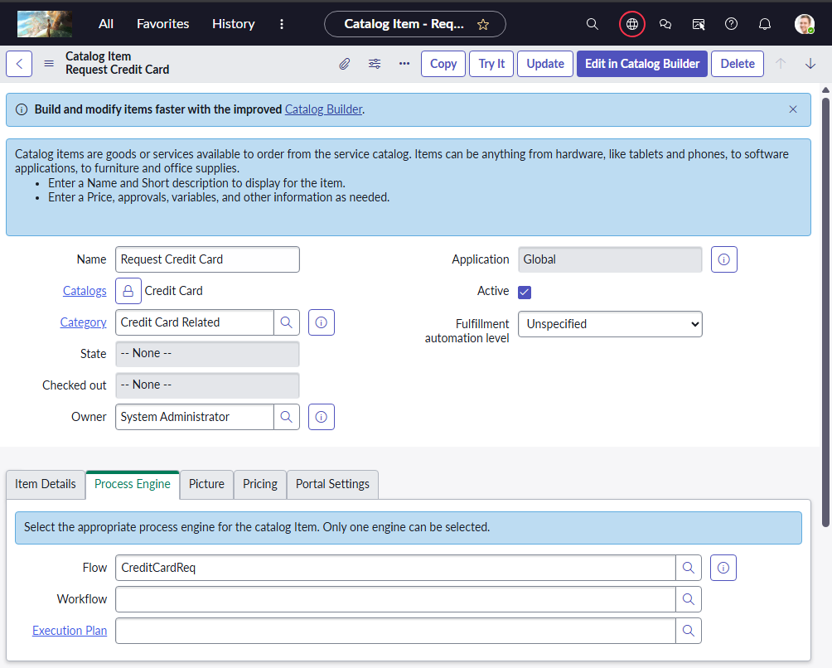Attaching the flow as Process Engine
     + 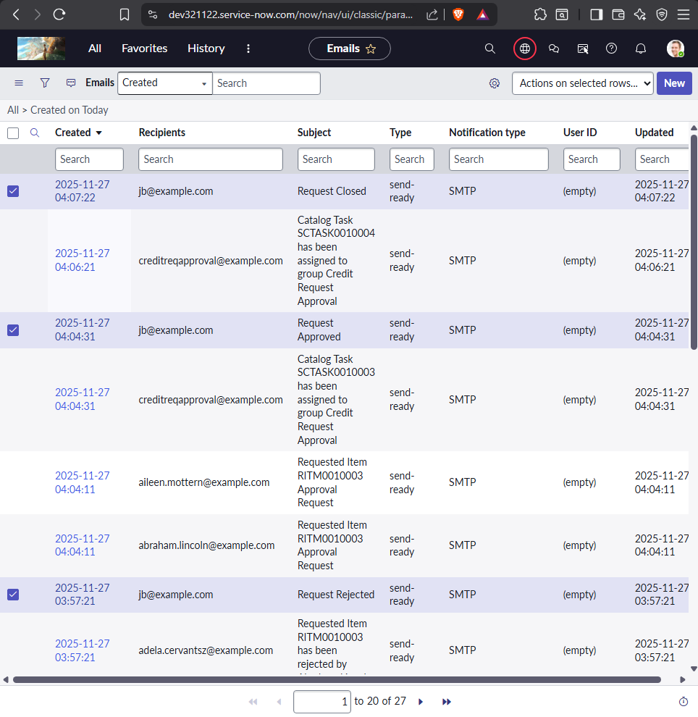email trigger for the user
2. 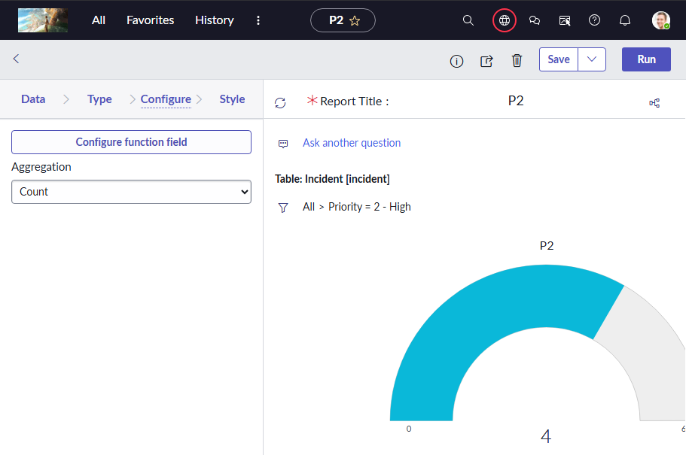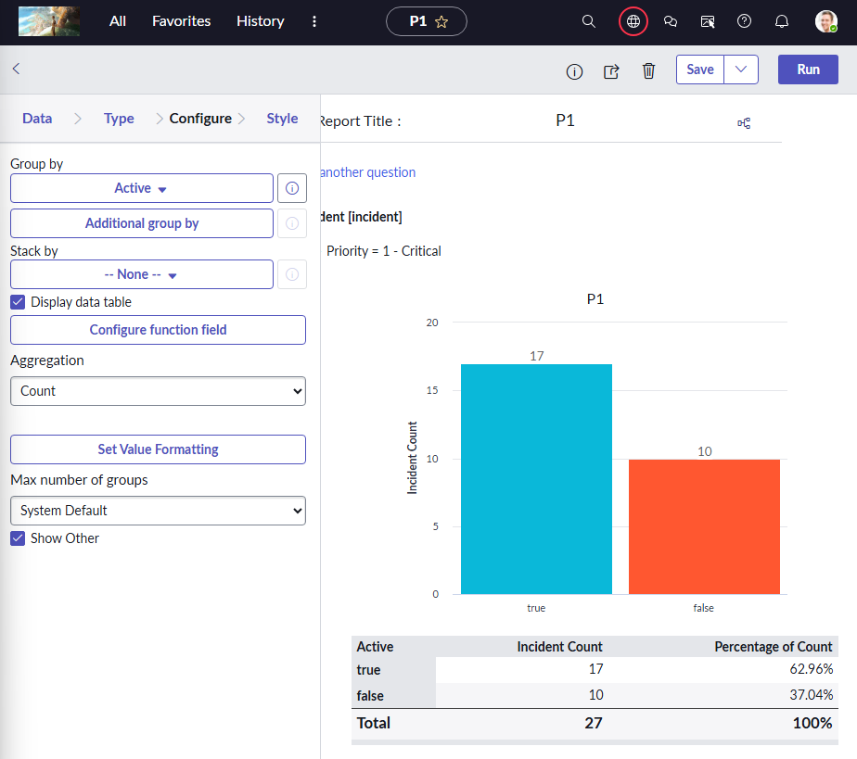Create A dashboard called Incident Priorities. ADD a P1 P2 P3 report of count type to respective dashboard.
   * 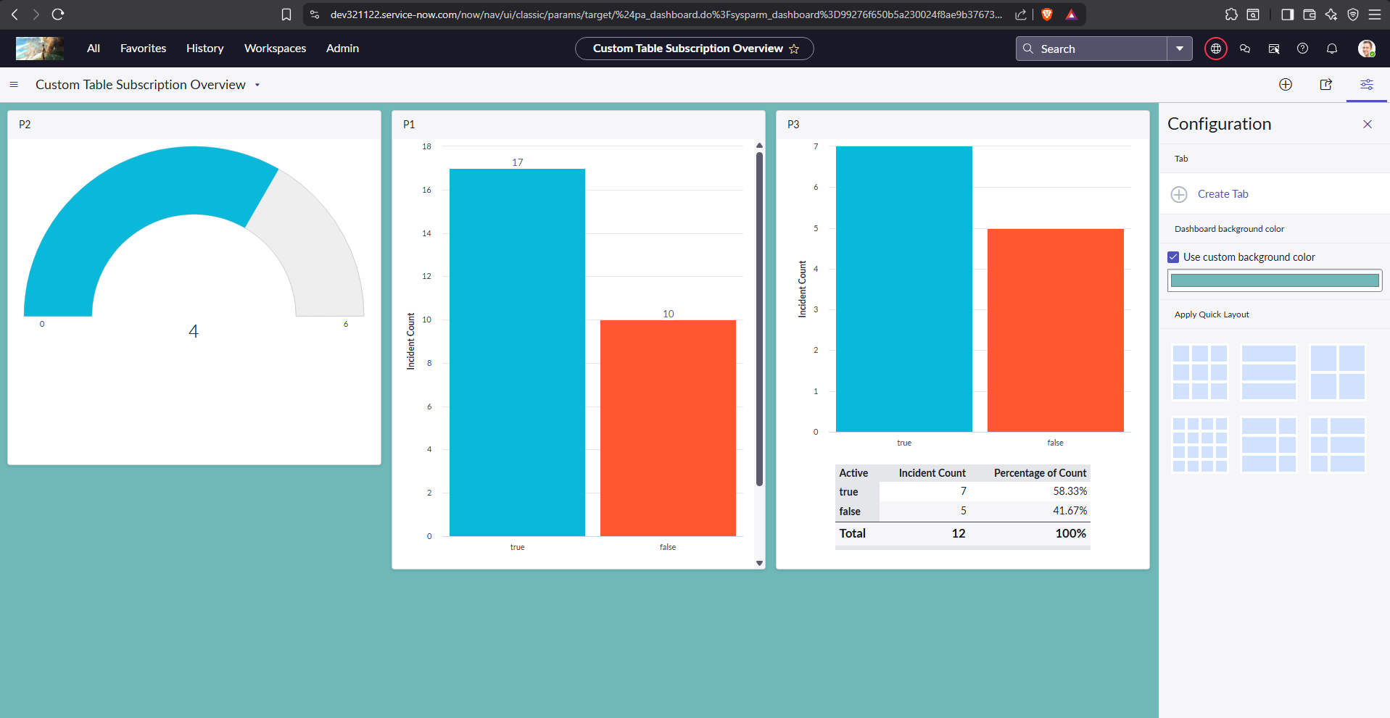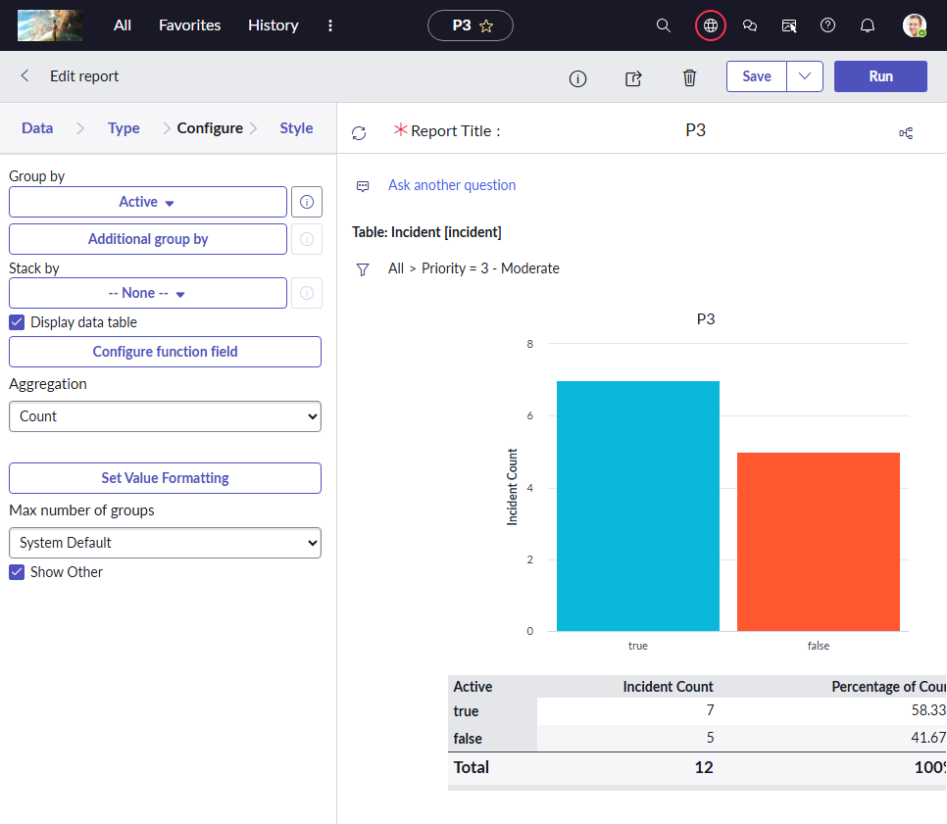DashBoard
3. Create a P1 , P2 , P3 reports , schedule it and send to one user
   * 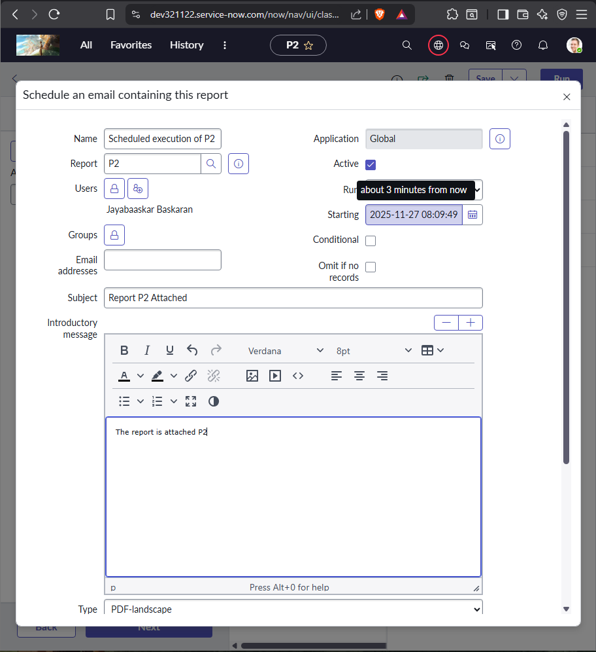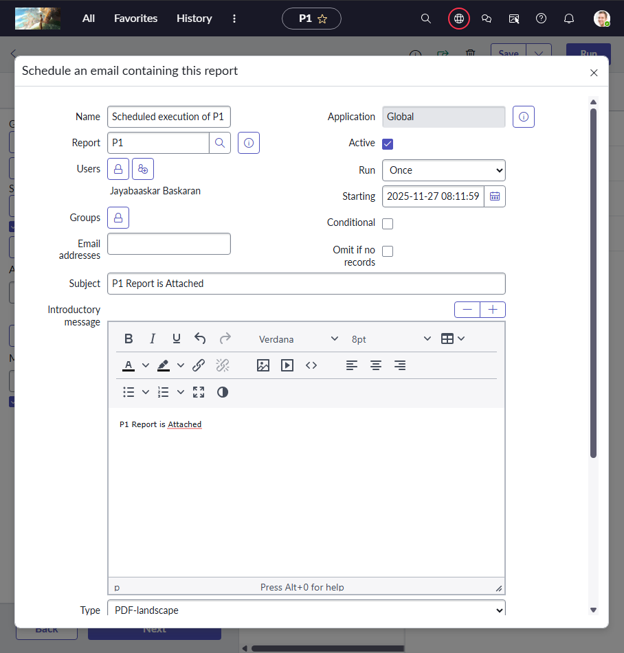Scheduling Report
   * 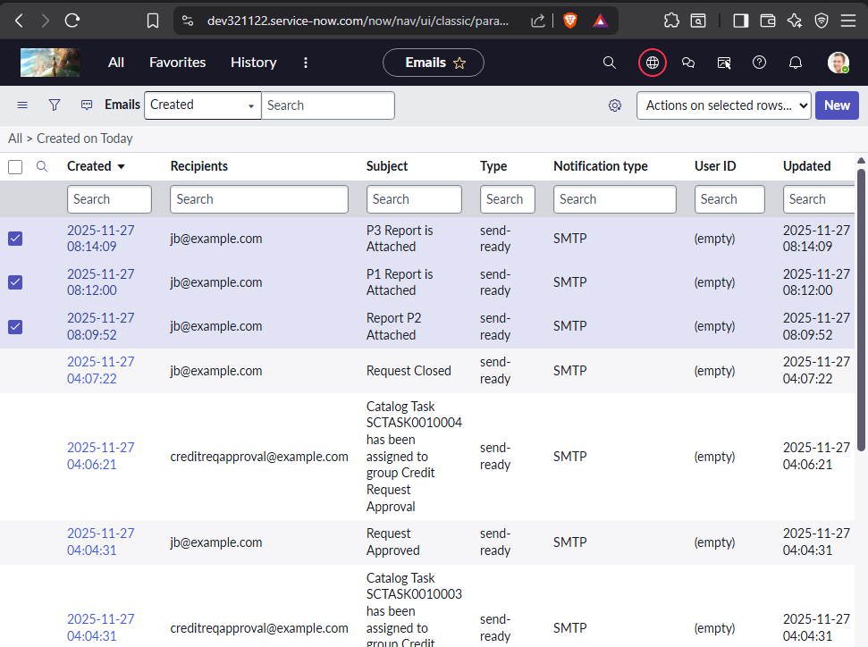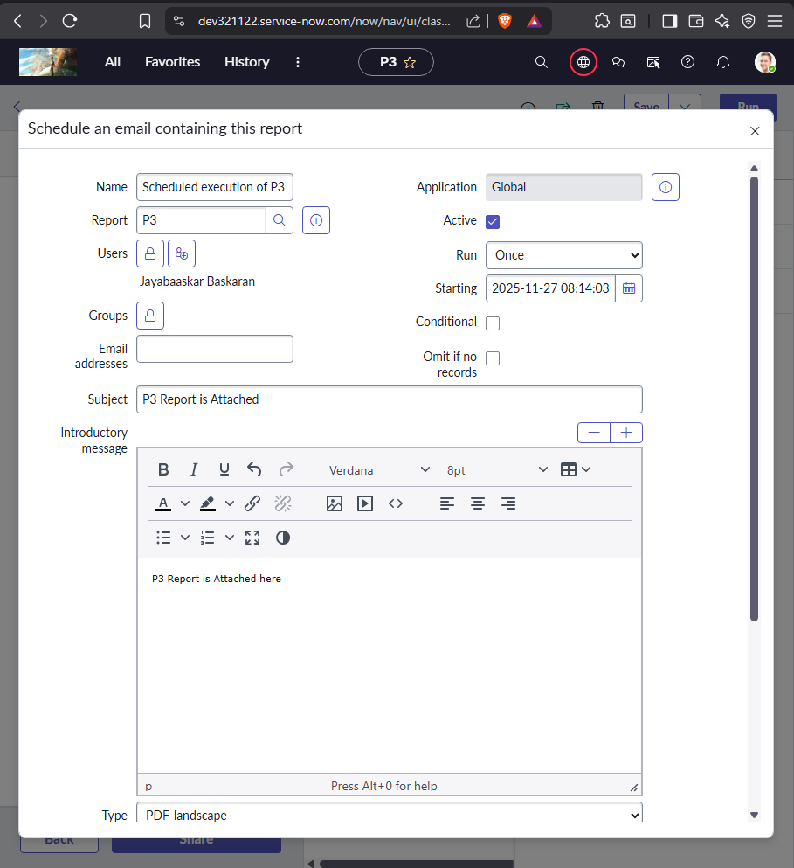Check if triggered on scheduled time
4. 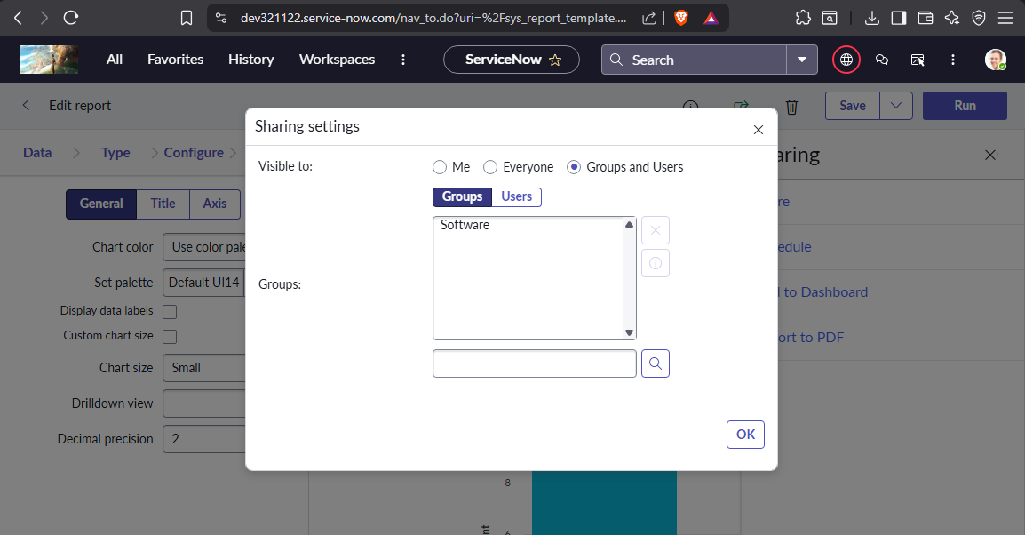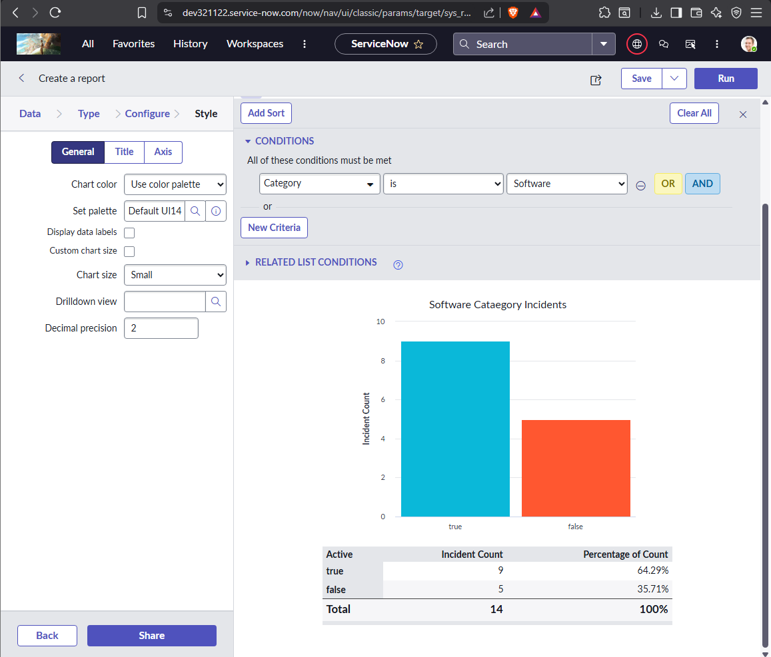Create a report to Find a software category incident in bar graph and share it and publish it to groups
5. Create Notification to opened by user when incident is inserted.
   * Sub : IncXXXX123 has been created.
   * 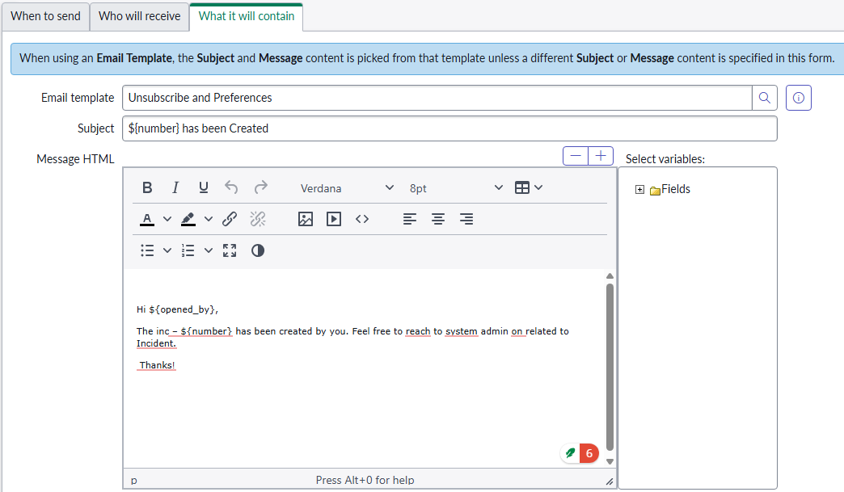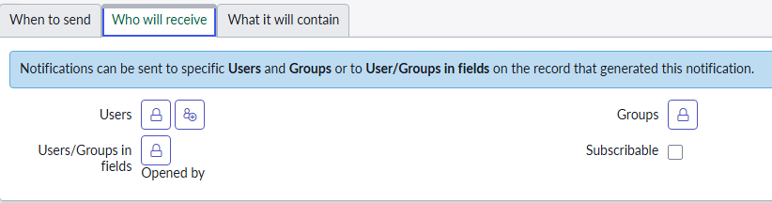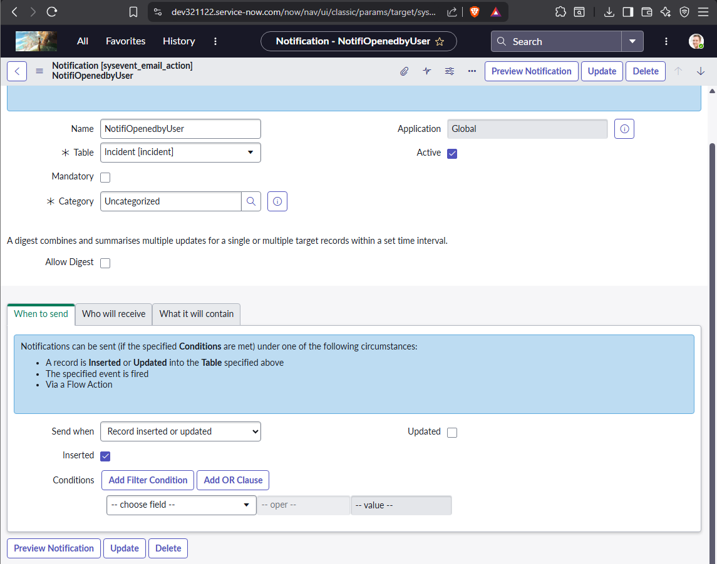Body : Hi XXXX, The inc –number has been created by you. Feel free to reach to syst em admin on related to Incident. Thanks!
   * 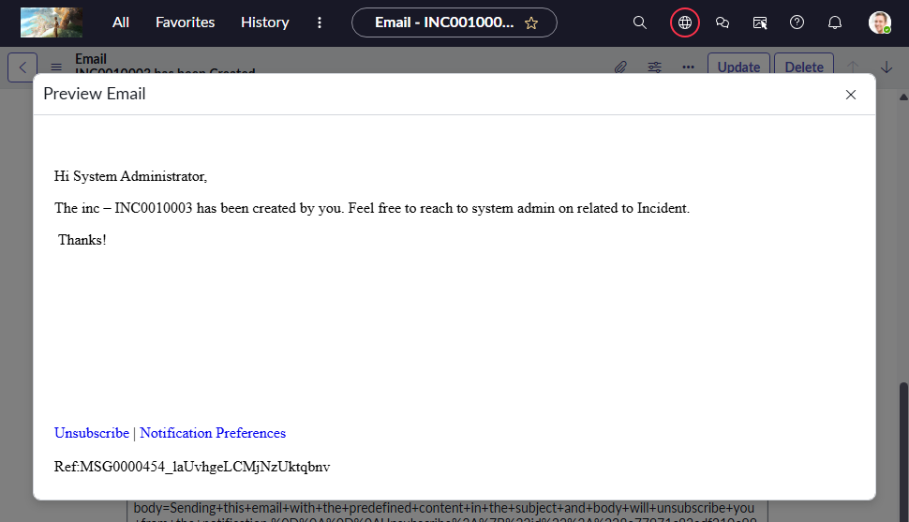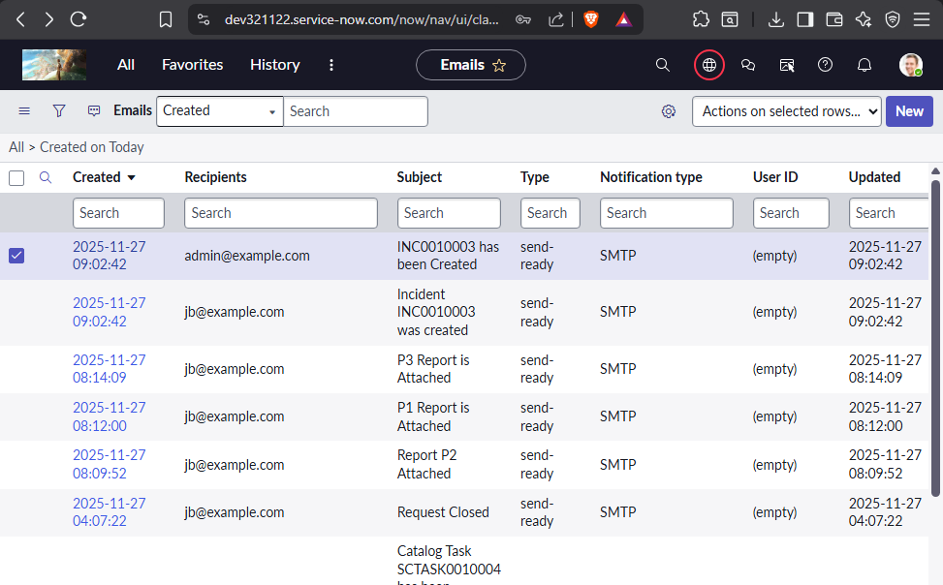Email Trigger check – All > System Logs > Emails.

1. Create a notification on update of incident to opened by. with the same body content as above.
   * Sub : IncXXXX123 has been updated.
   * 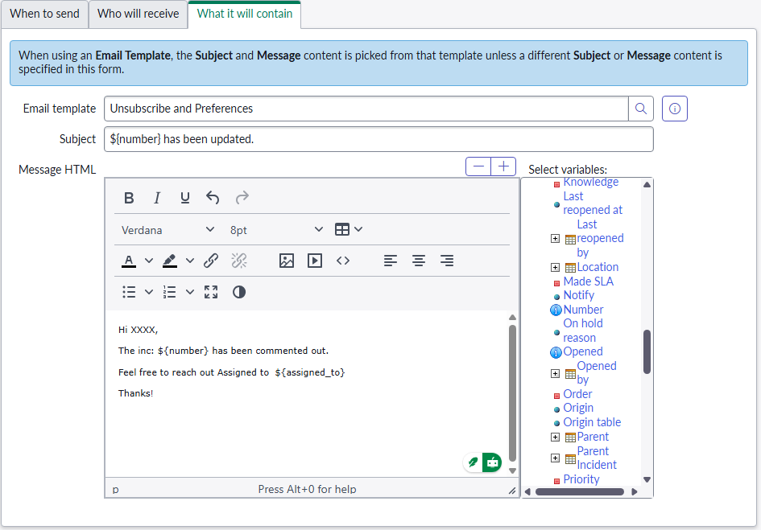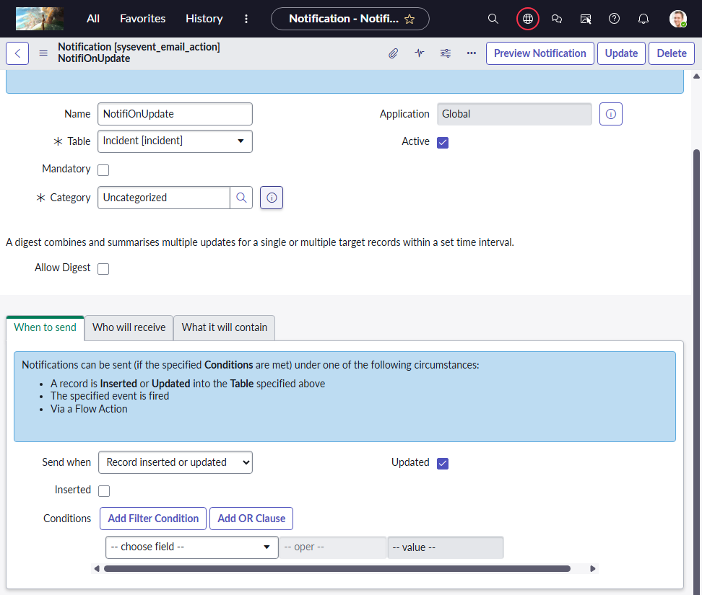Body : Hi XXXX, The inc –number has been commented out Feel free to reach out Assigned to {assigned to person name} Thanks!
   * 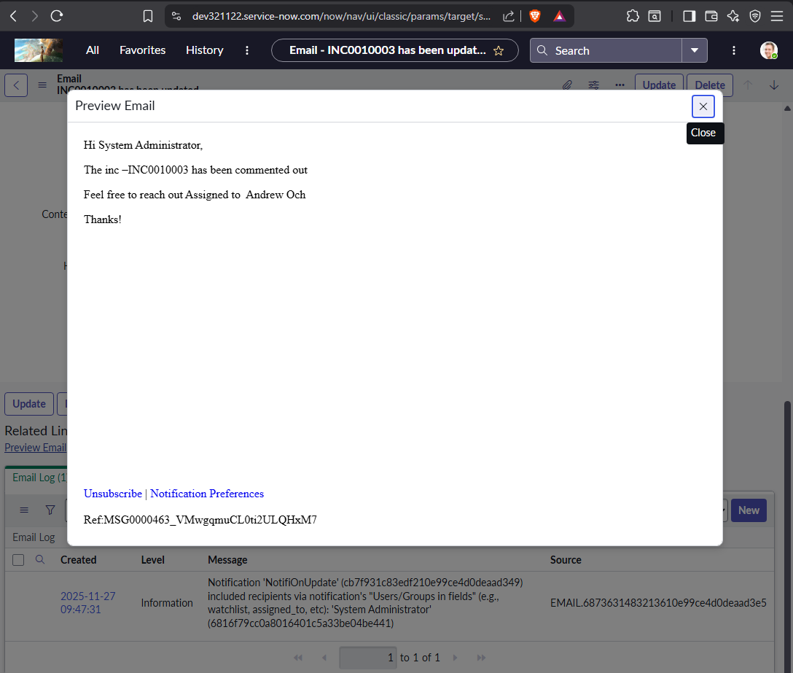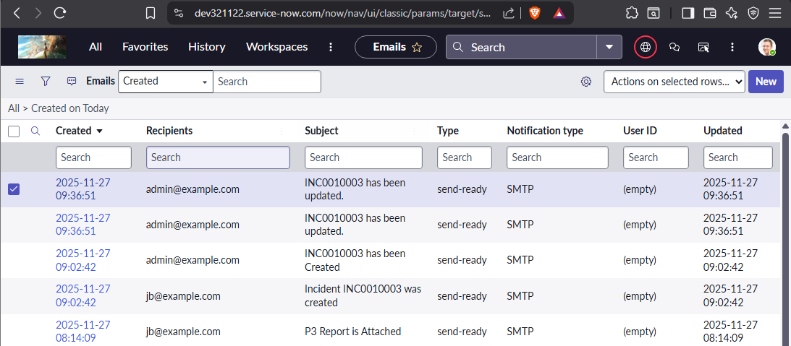Mail Log Check
2. 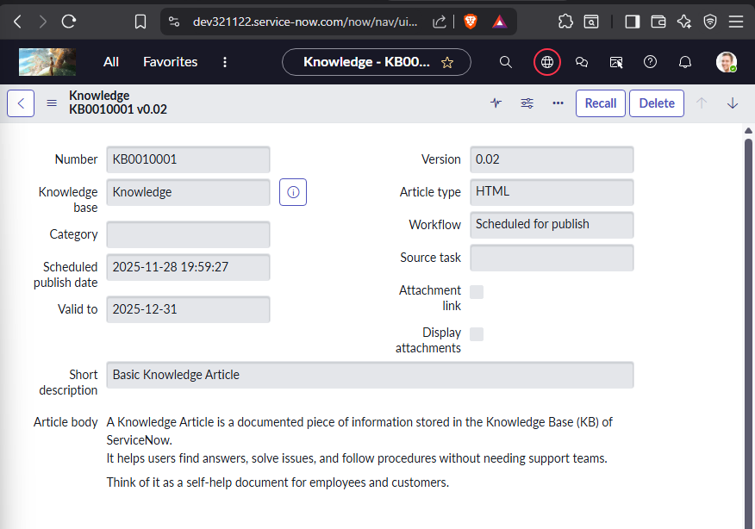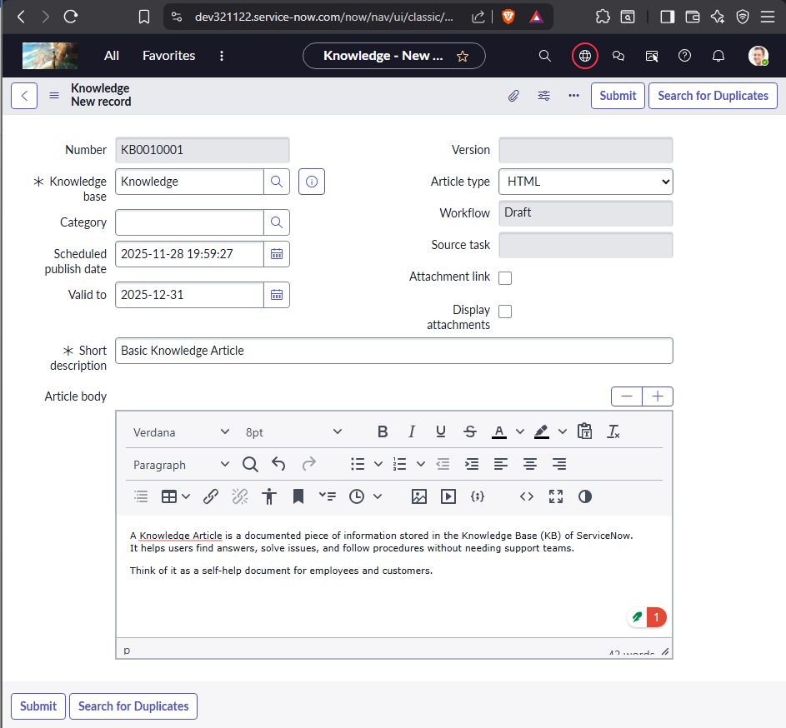Create a Basic Knowledge article and publish them and retire them. Content: off your own choice.

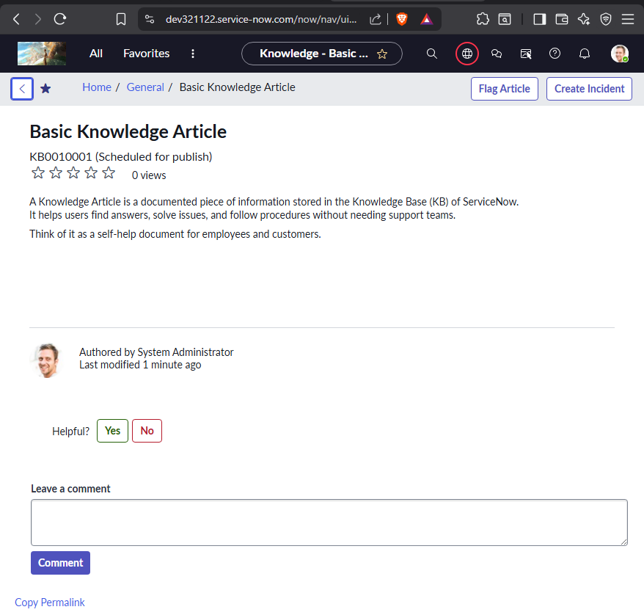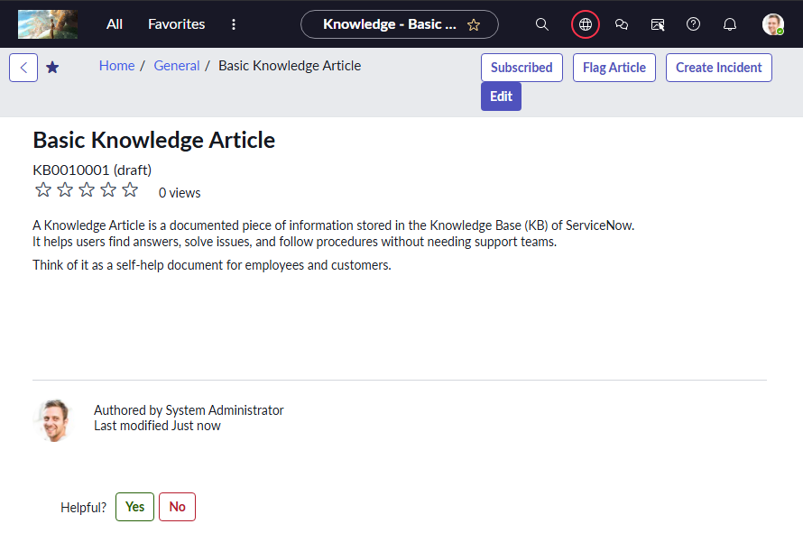

1. 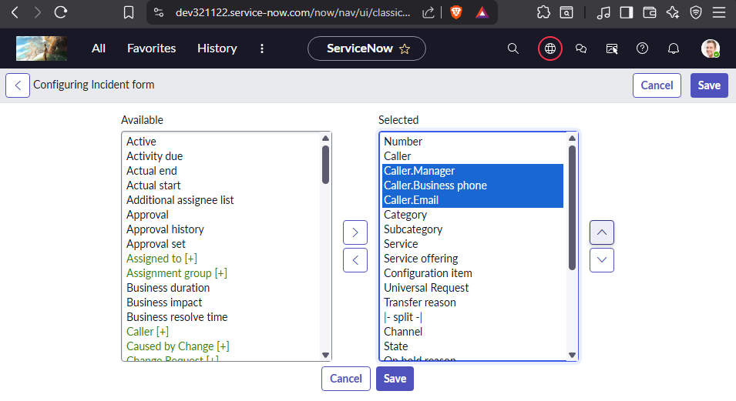On incident form create a custom field called manager, phone number and Email. On select of caller the caller details need to be auto populated.
   * 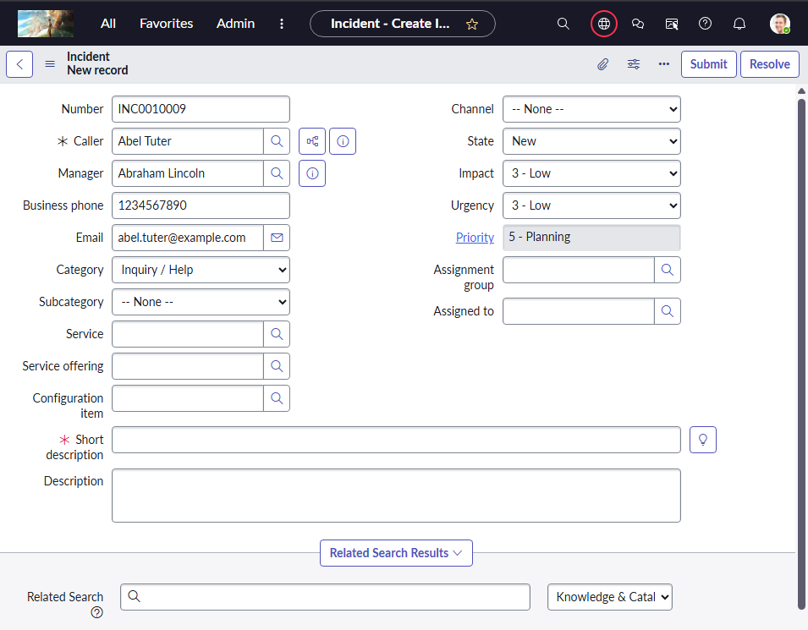Dot walk caller manager phone and email
2. 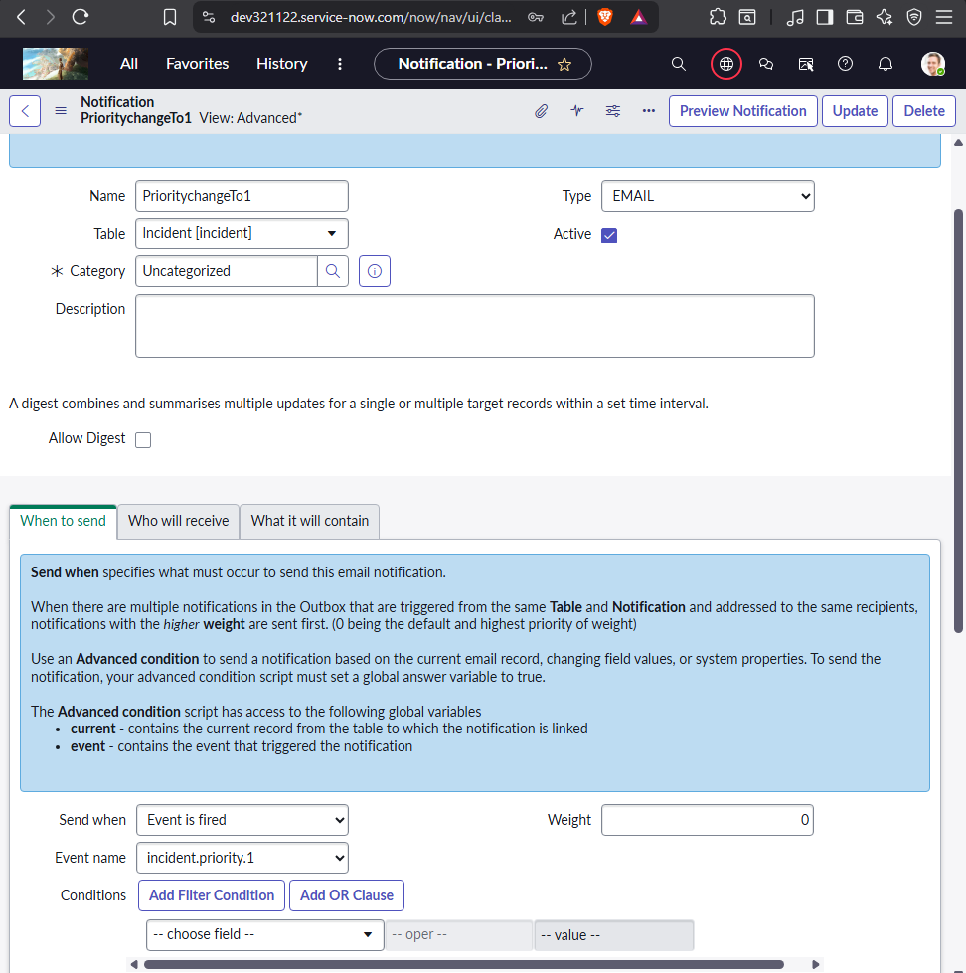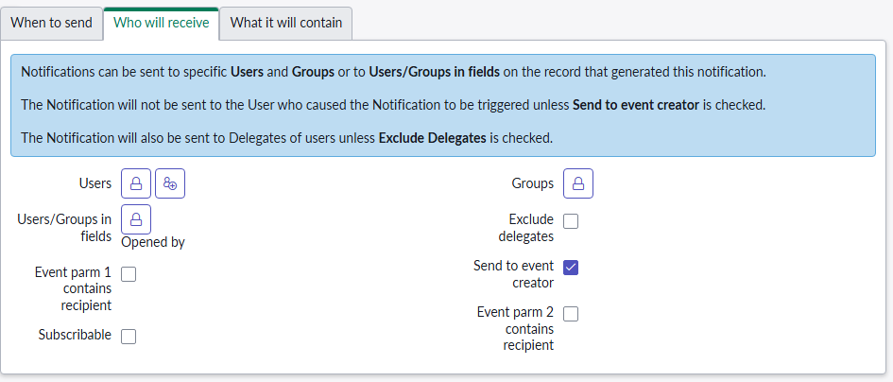Trigger a notification to opened by user through event when priority changes to P1.. Body content of your own.

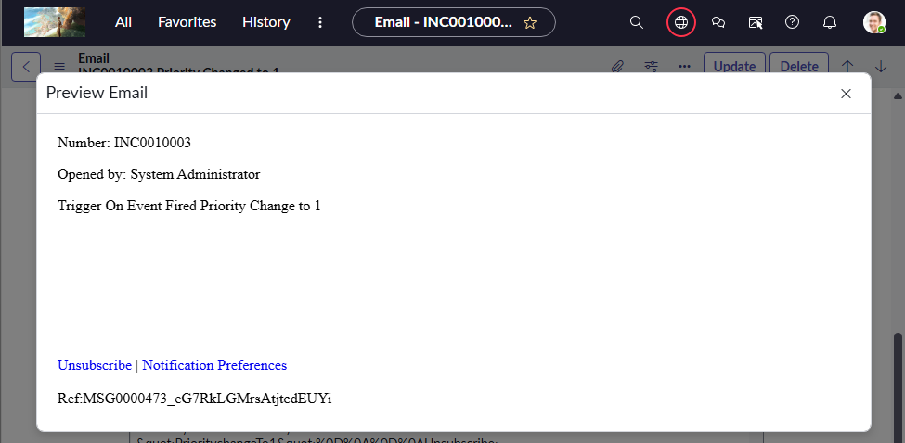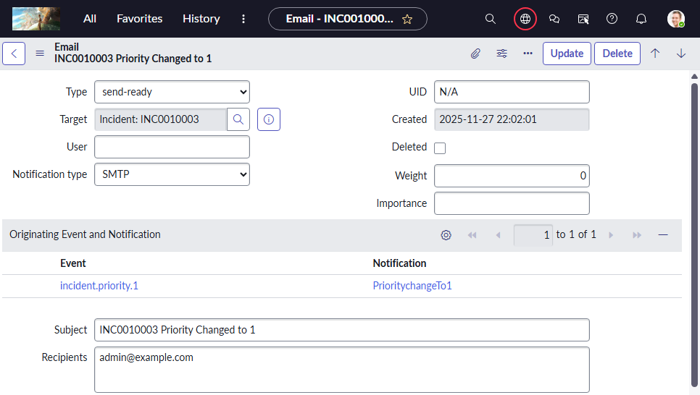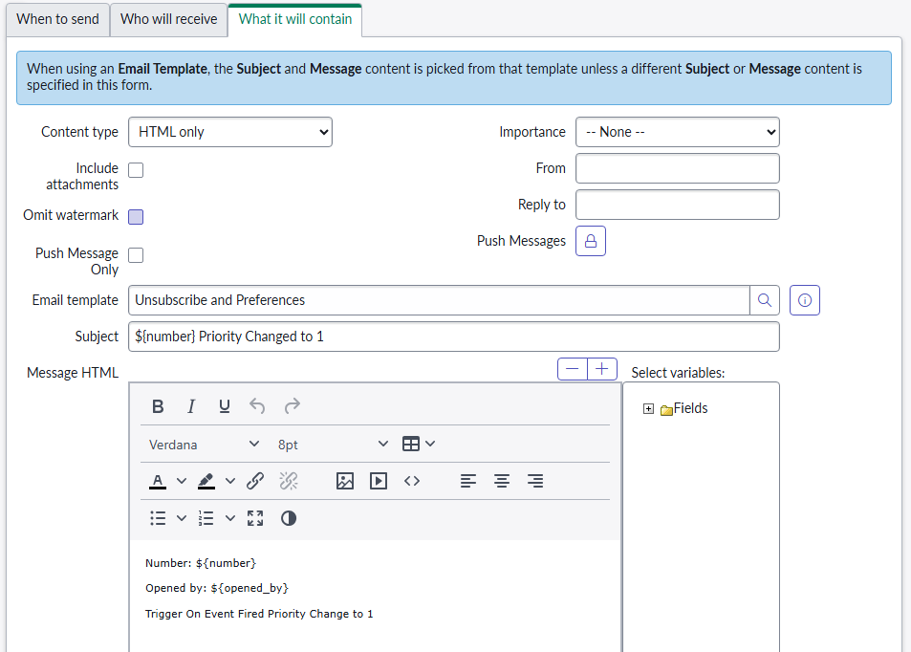

1. Capture below client script on a update set and move to other pdi
   * 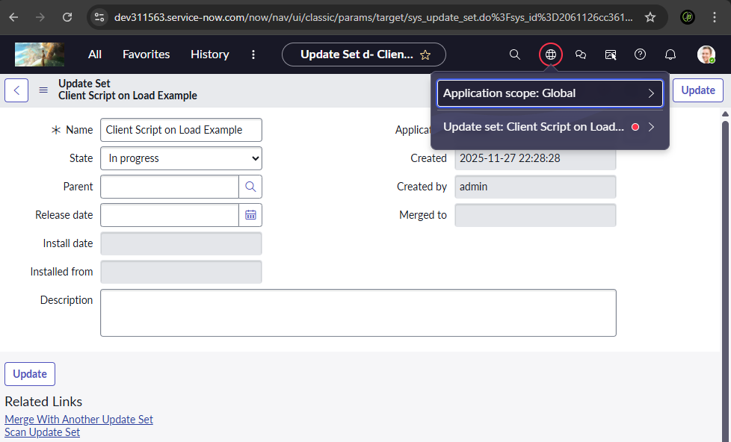ex: update set name: Client script on load example
   * Create an on change client script on incident When user change the caller the:
     + 1) Email of that changed caller will be displayed in the email field.
     + 2) CI field become mandatory.
     + 3) State field value will change to In-Progress
     + 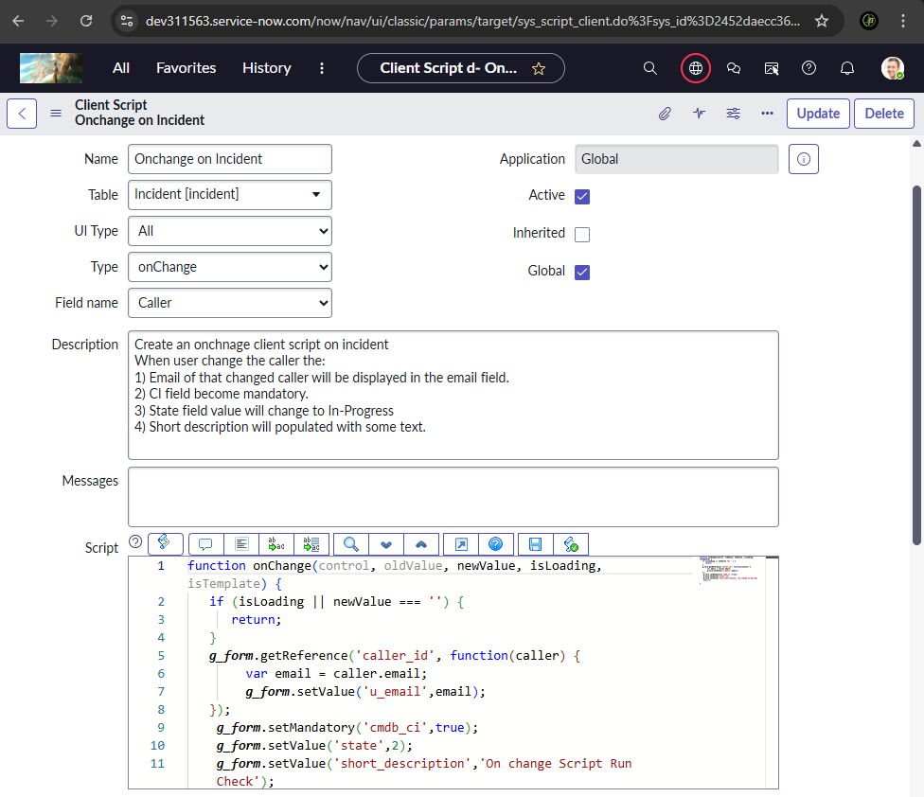4) Short description will populated with some text.
     + Complete Update set and Move to Other PDI
       - Export this Update set to XML
       - 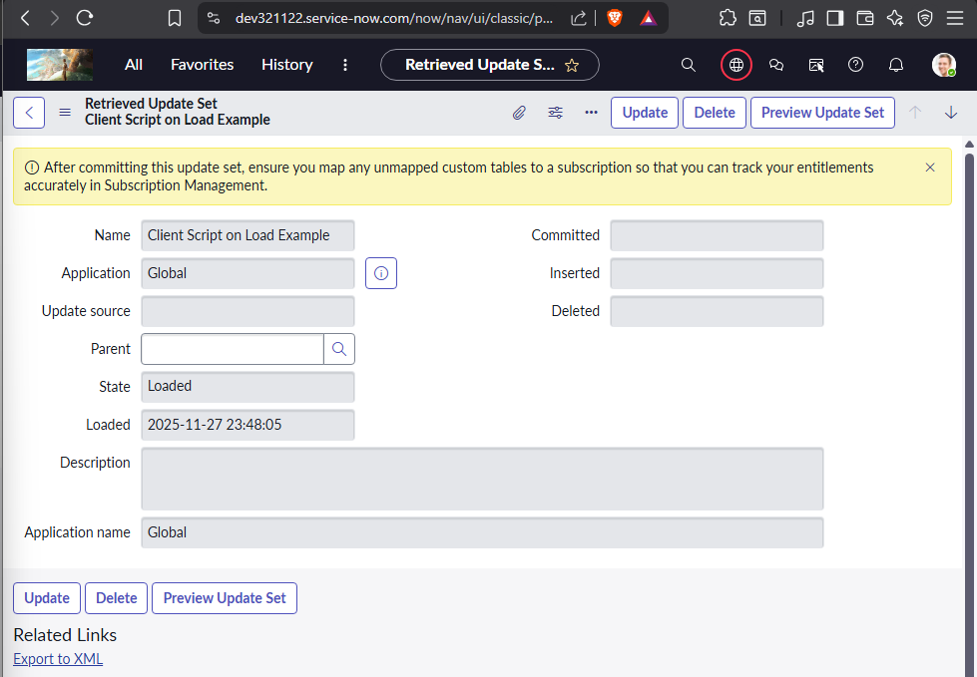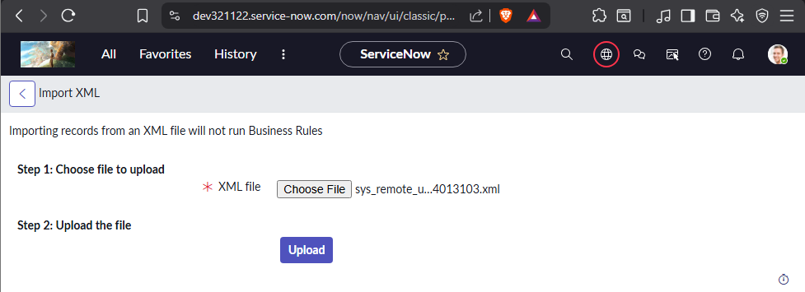Go to Retrieved Update Sets and Import this Update set
       - 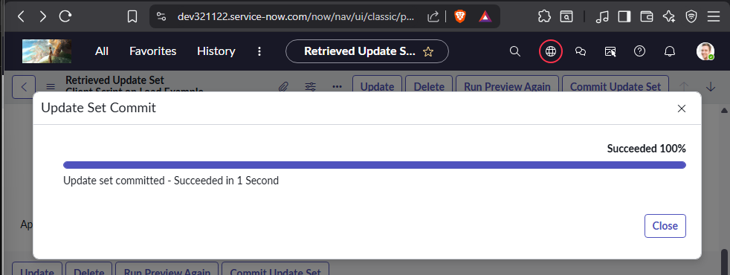Preview Update Set and Commit Update Set
       - 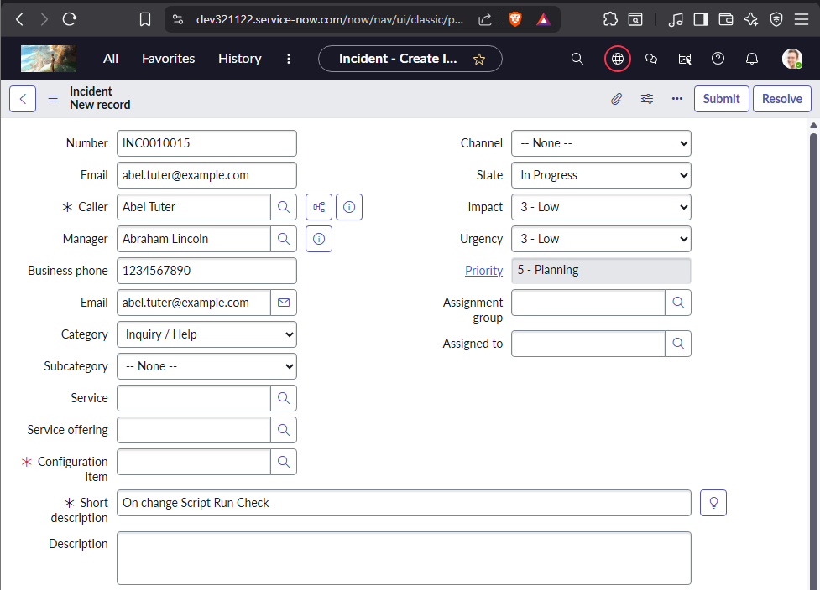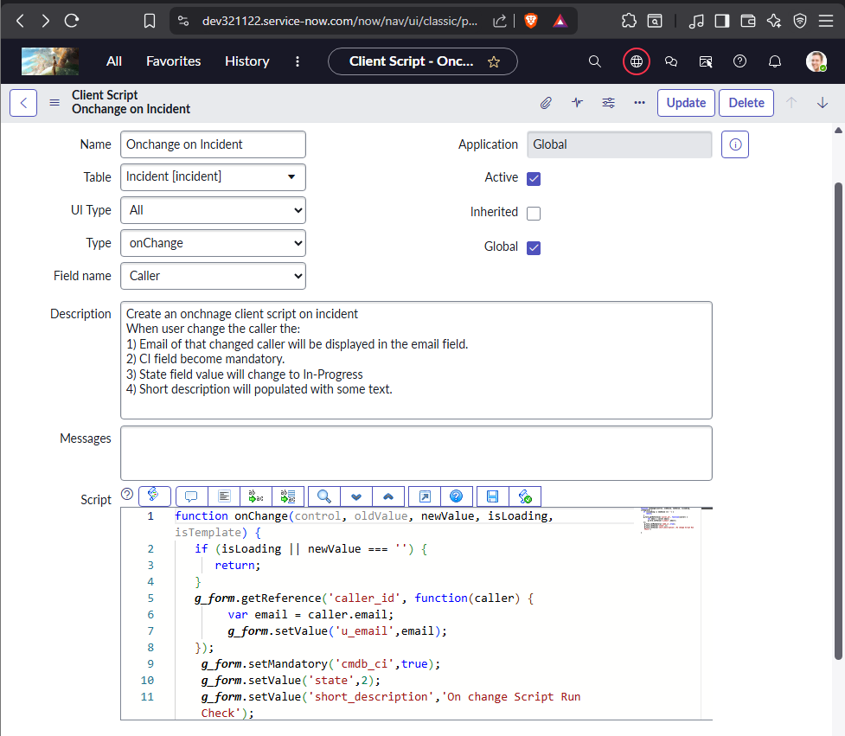Check if the Client script is imported and Functional
2. Create a On Submit client script on incident
   * Create custom fields on form called Issue dated on and Issue resolved on
   * We have to compare two dates on Submit Client script.
   * 1) If “issue resolved date” field date is greater or equal to” issue dated on “filed date then form will get submitted
   * 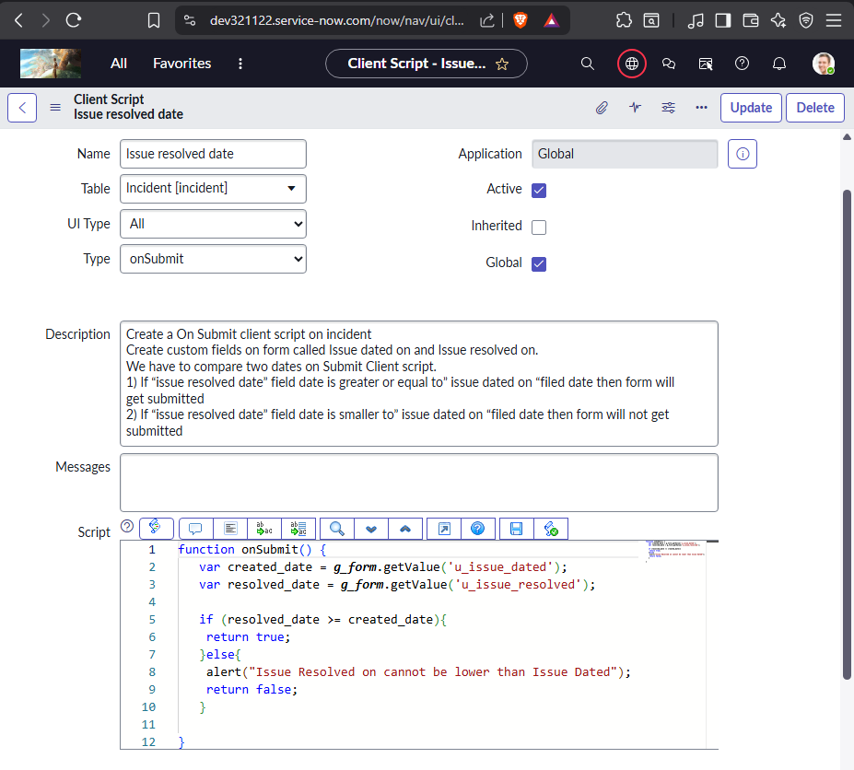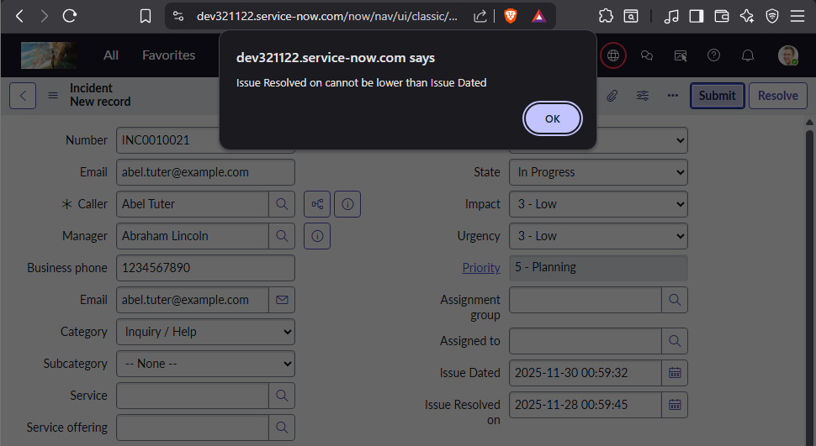2) If “issue resolved date” field date is smaller to” issue dated on “filed date then form will not get submitted
3. Create a On Submit client script on incident
   * 1) will make email filed mandatory read only.
   * 2) CI field become mandatory.
   * 3) will add a status choice “pending with admin” for users having admin role
   * 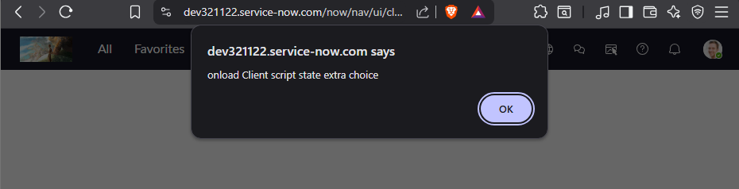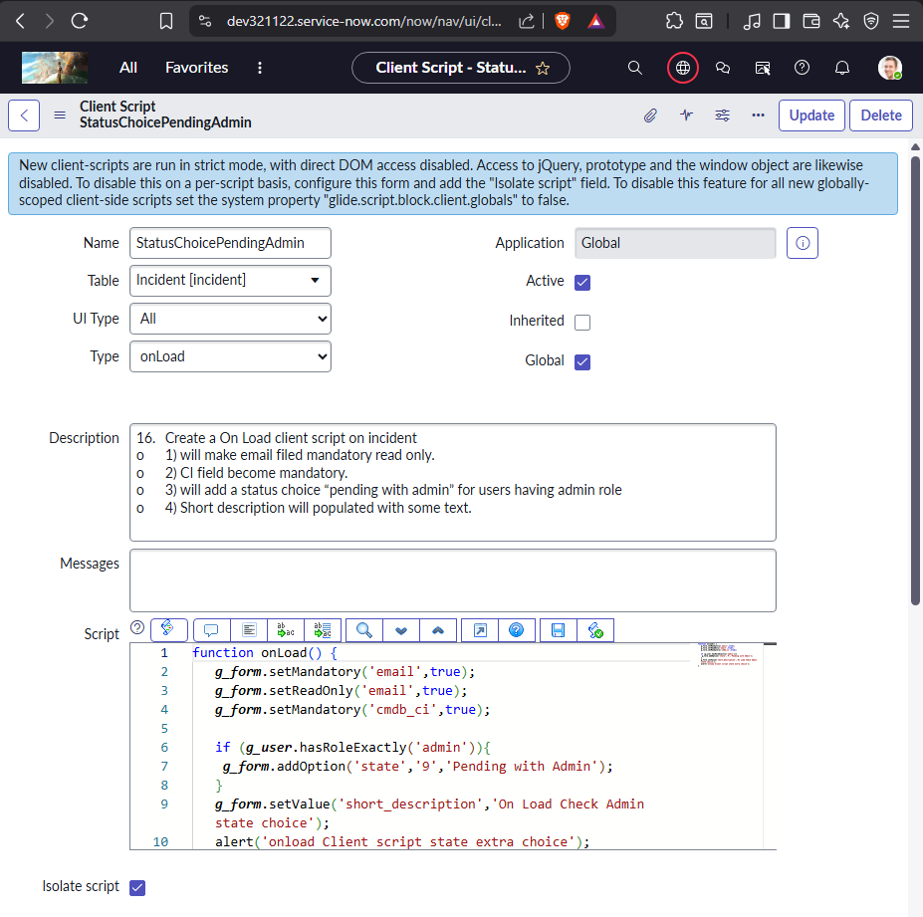4) Short description will populated with some text.

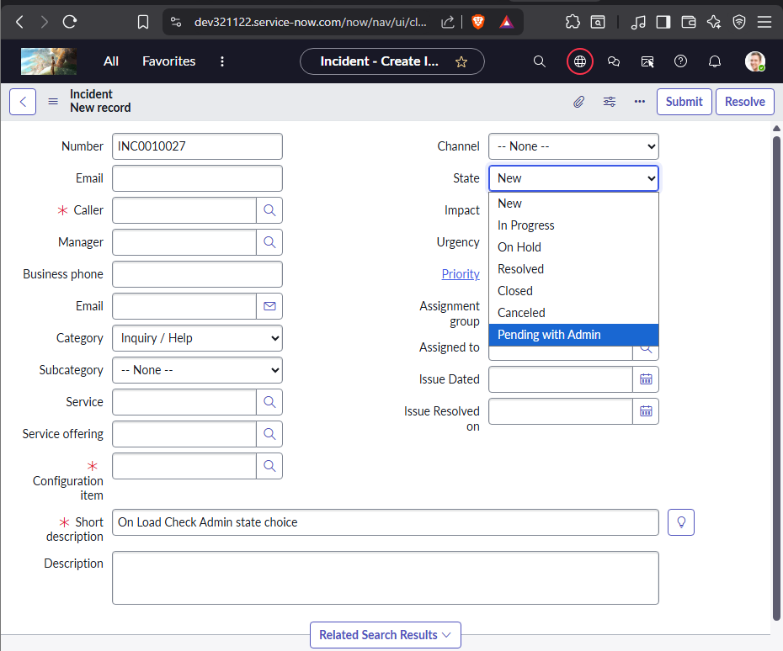

1. Create a UI Policy
   * 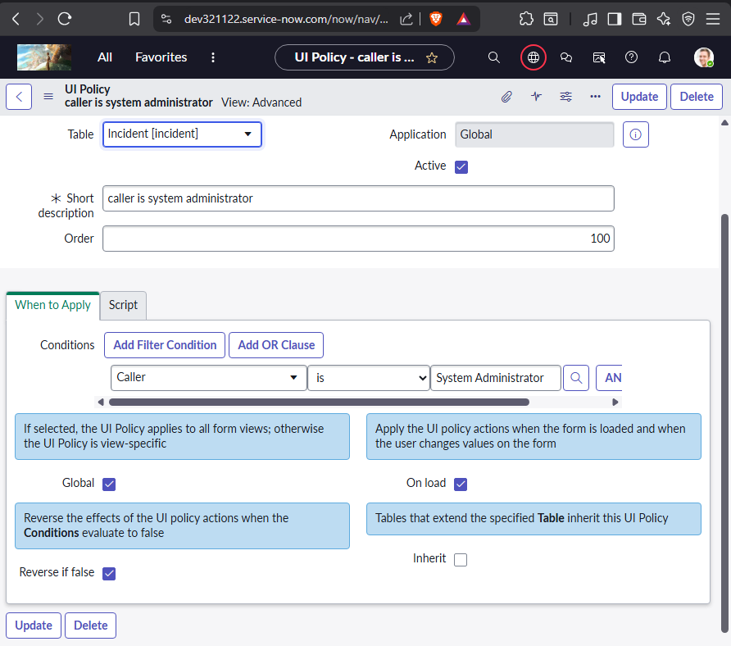When the caller is system administrator then email mandatory, phone number hidden and manager is read only
2. 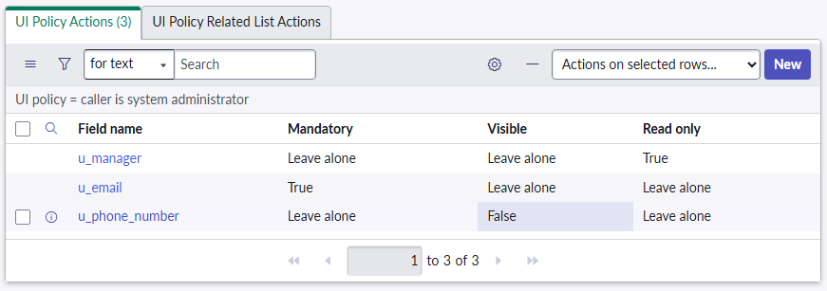 Create a custom table—User details
   * Name - Reference type (sys_user)
   * Email Id - String
   * Address - String
   * Mobile No - String
   * 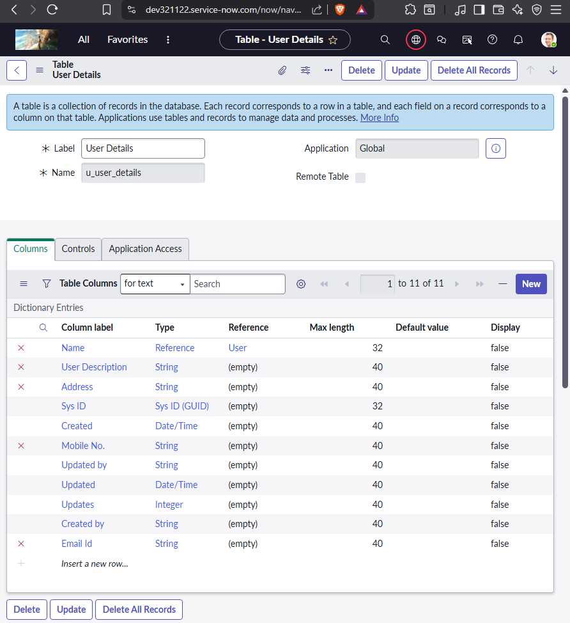User Description - String
3. Scheduled Jobs
   * 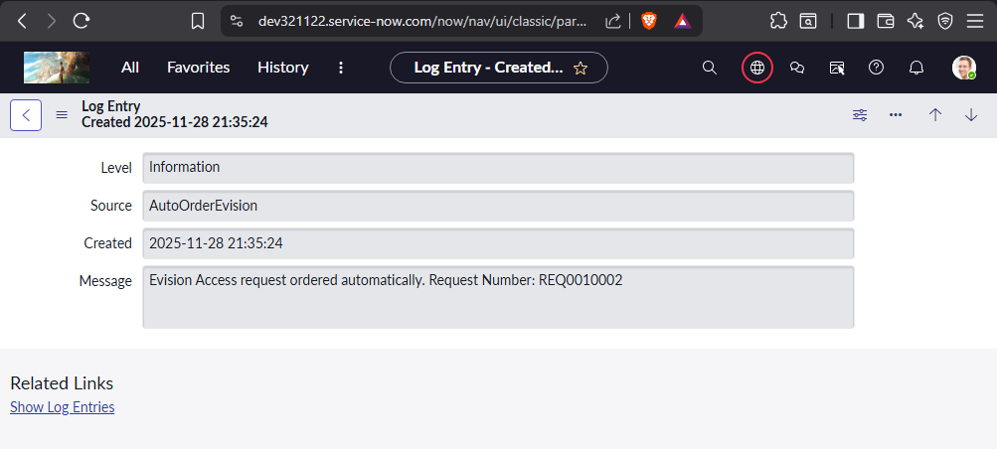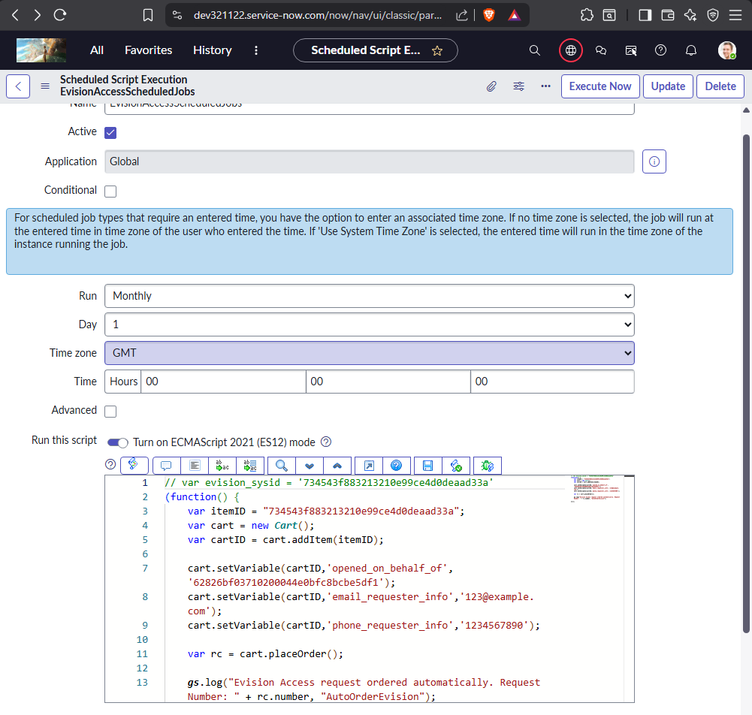Order the catalog item Evision access by using a schedule job every month on day 1.
   * 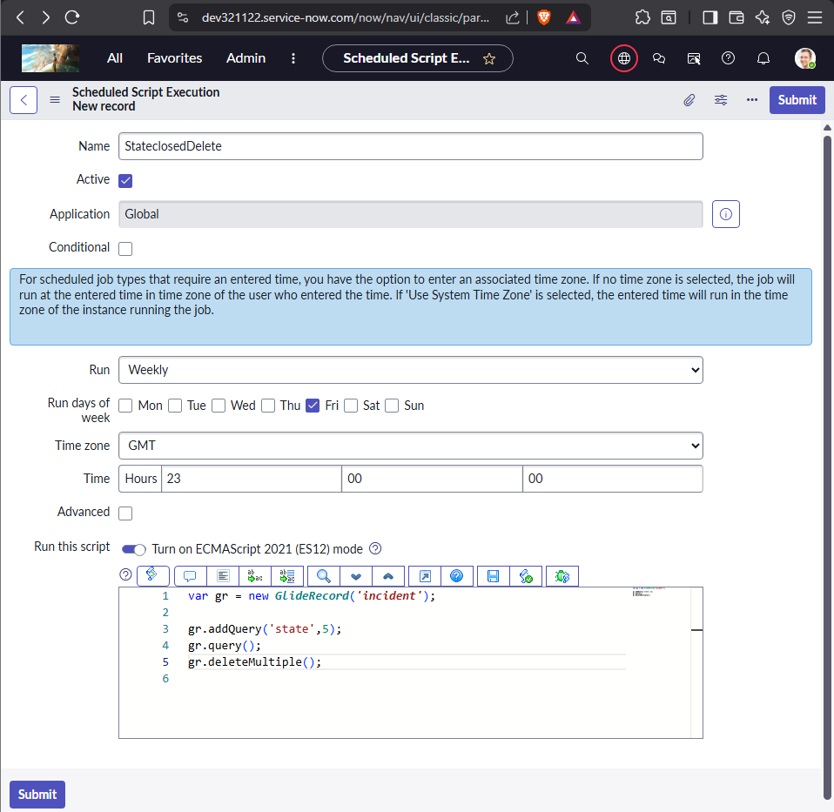Delete all closed incident tickets every week on friday.
   * 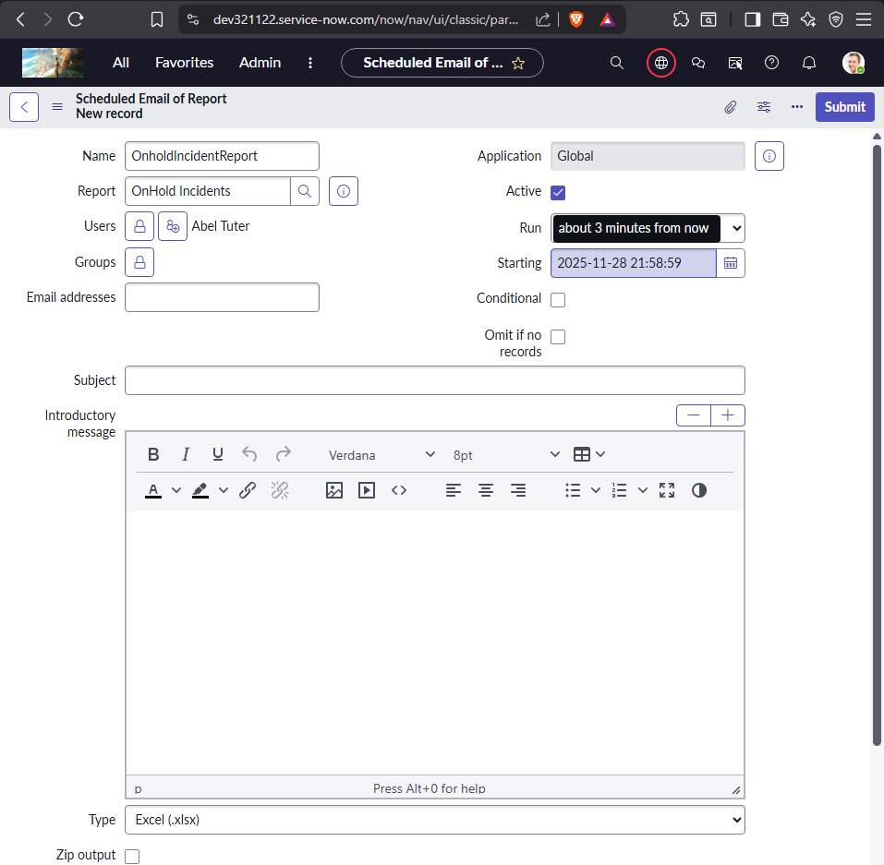Send all on hold incidents tickets report to the Manager with Excel format.
   * 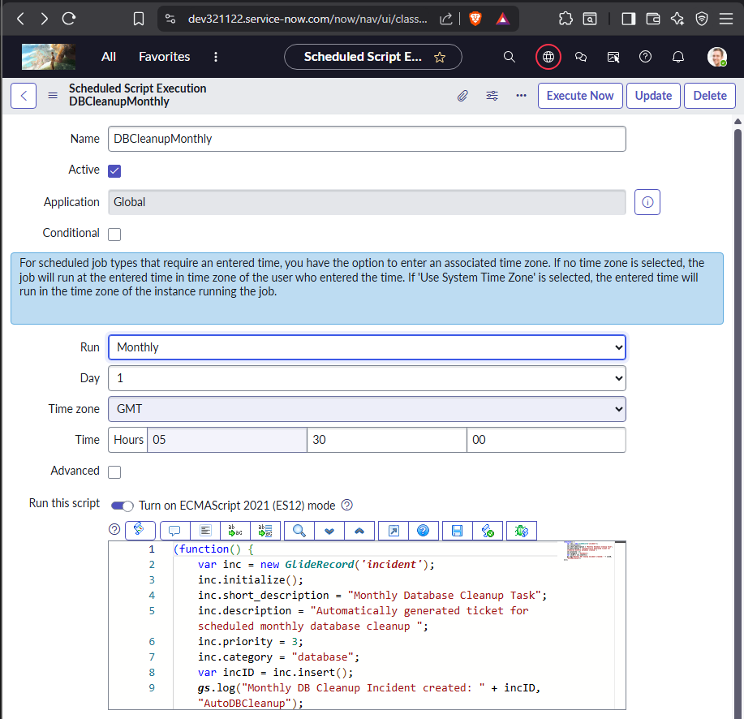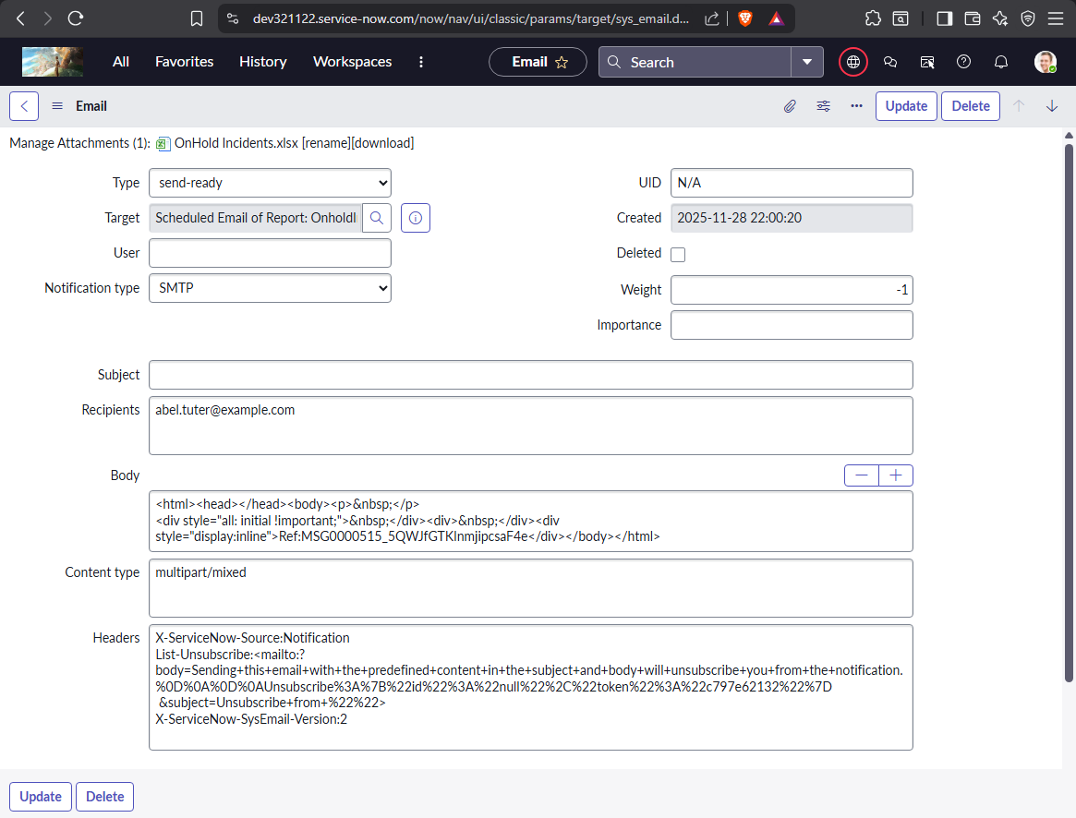Automatically Create the database cleanup incident ticket on every month day1.
   * Automatically load the data into the User table with schedule import by using data source it should load every day 10AM.
   * 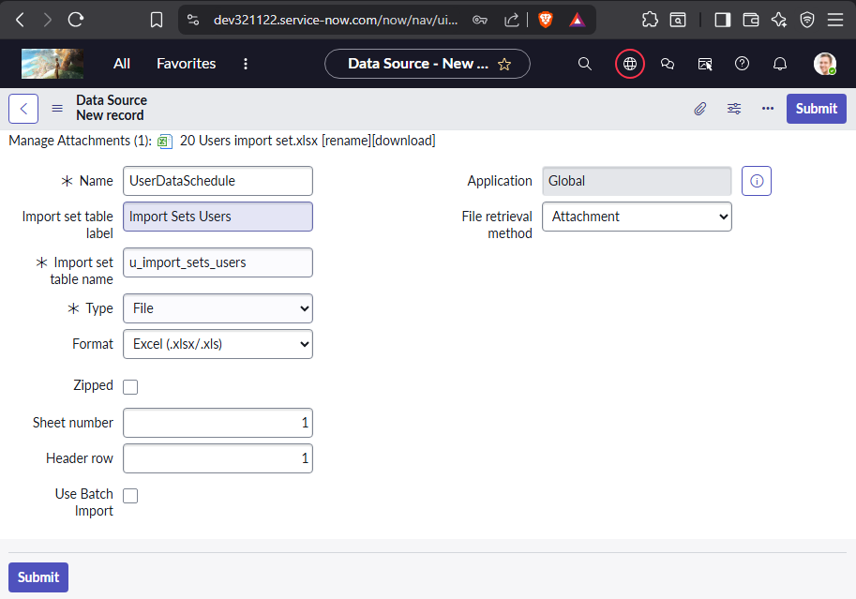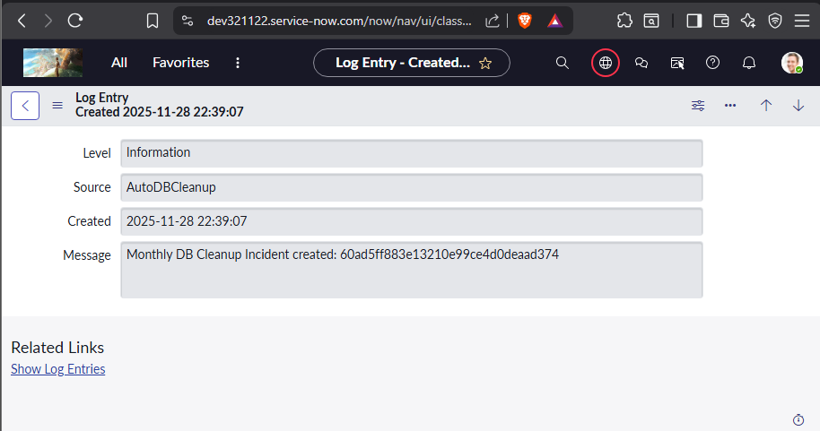create a data soure with type file and format excel – attach the file
   * 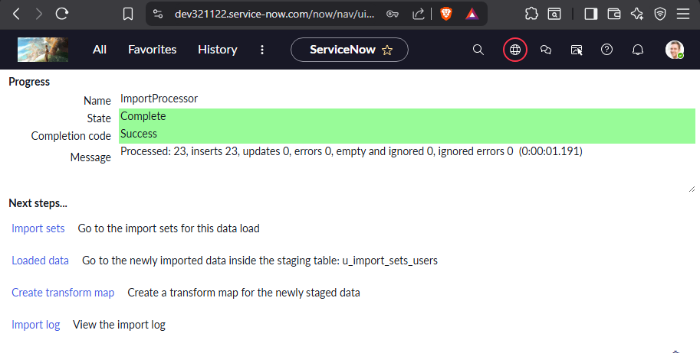Load all records
   * 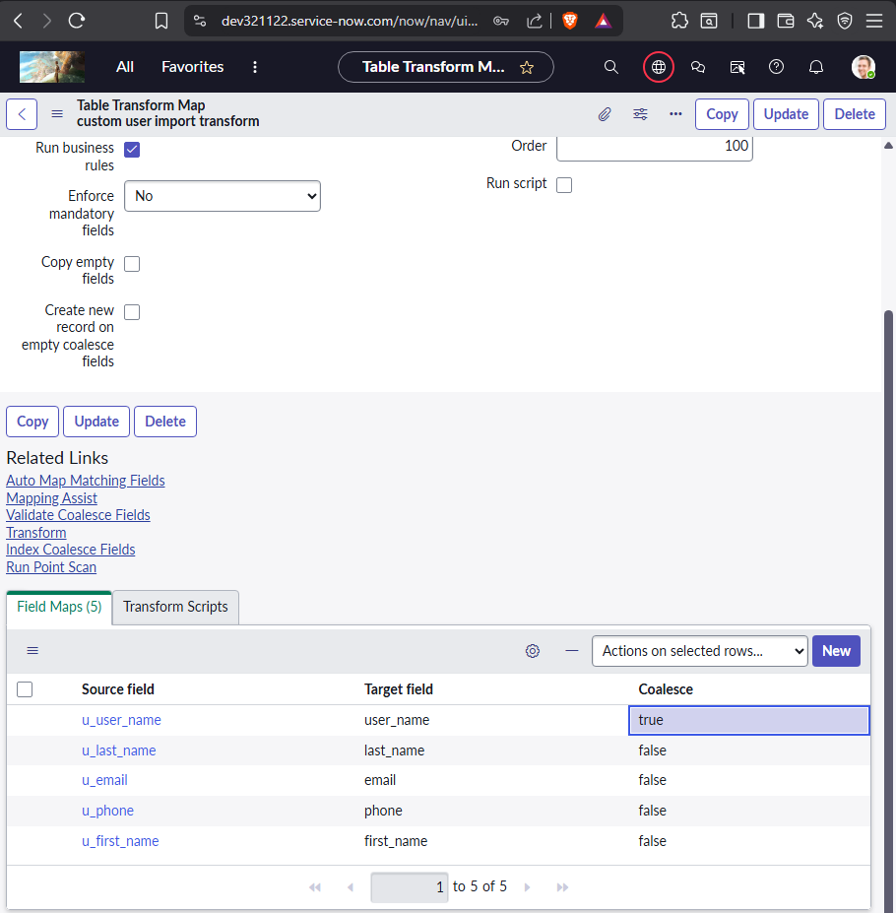Create proper transform map with assist and set coalesce field
   * 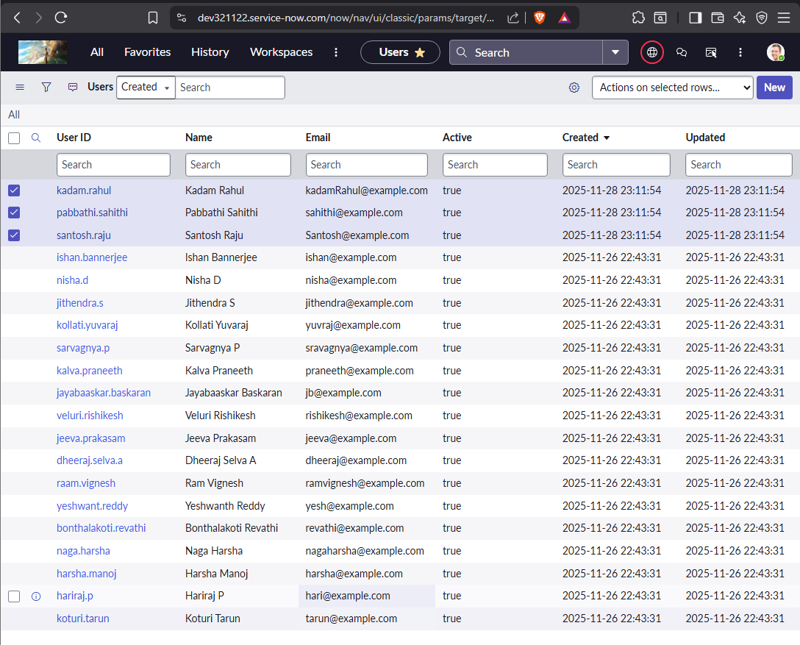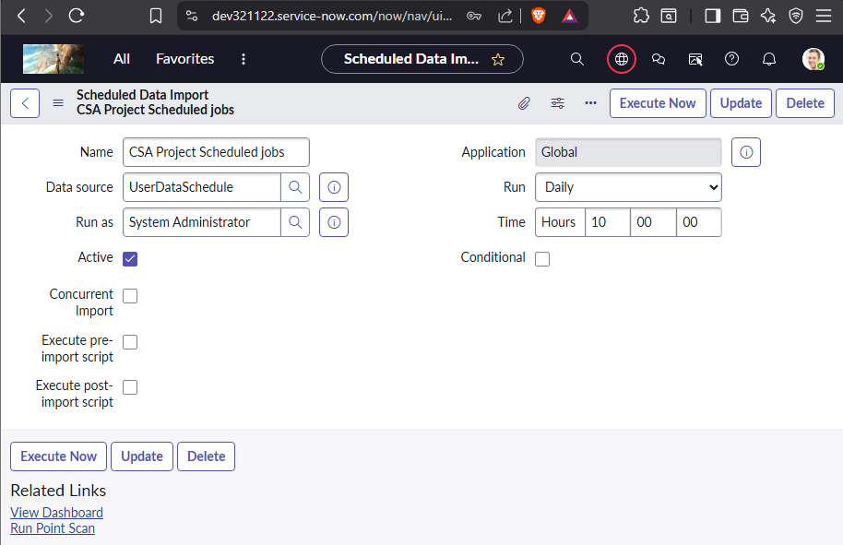Go to All > Scheduled Imports > Create New > Select the Data Source created
   * Execute Now to Verify Process
4. 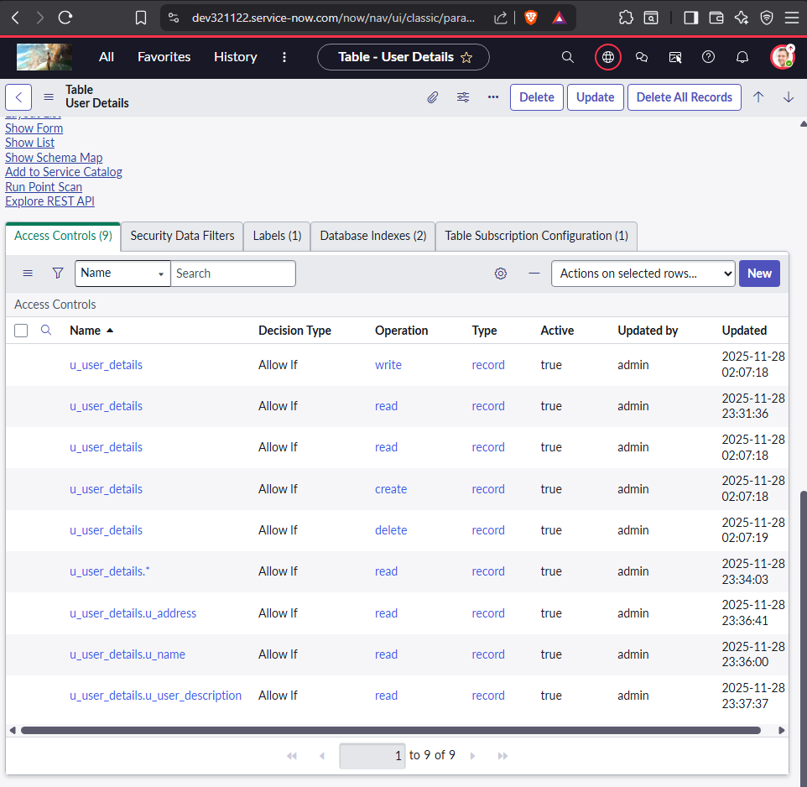 Role A users—name, address, user description
   * 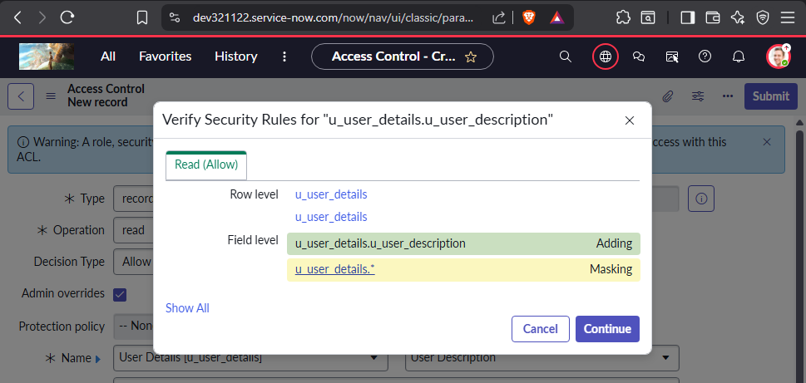Role B role users -→access all fields.
   * 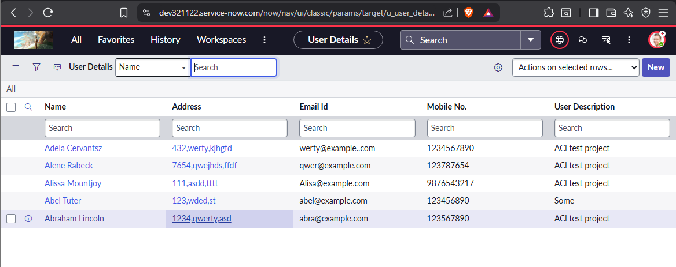Admin view of the table
   * Impersonate with each user and view the table u_user_details
     + User A view – Role A
       - 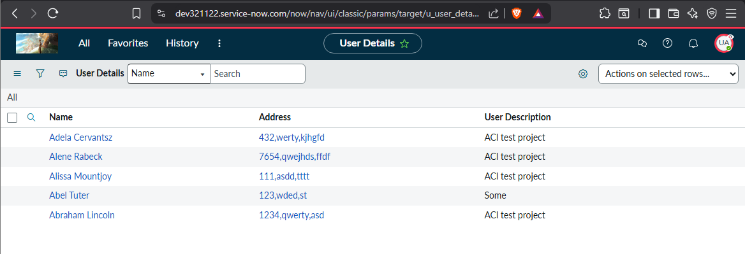Has Name,Address,User description Read Acl
     + User B view – Role B
       - 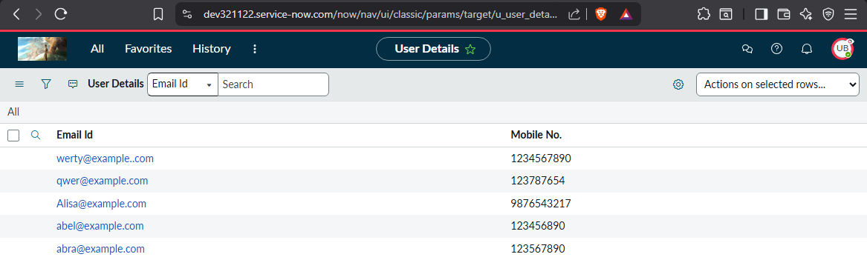Has Table.* - Read ACL (All Fields)

(Both Role A and Role B are provided with Table*None Read Access)